INVESTIGATION OF THE FLOW DYNAMICS OF A VERTICAL

BIOREACTOR USING THE RESIDENCE TIME DISTRIBUTION

by

Mark Edney

BEng Ryerson University 2011

A thesis presented by Ryerson University

In partial fulfillment of the

requirements for the degree of

Master of Applied Science

in the program of

Chemical Engineering

Ryerson University

Toronto, Ontario, Canada, 2020

© Mark Edney, 2020

August 8, 2020

# Author’s Declaration

AUTHOR’S DECLARATION FOR ELECTRONIC SUBMISSION OF A THESIS

I hereby declare that I am the sole author of this thesis. This is a true copy of the thesis, including any required final revisions, as accepted by my examiners.

I authorize Ryerson University to lend this thesis to other institutions or individuals for the purpose of scholarly research.

I further authorize Ryerson University to reproduce this thesis by photocopying or by other means, in total or in part, at the request of other institutions or individuals for the purpose of scholarly research.

I understand that my thesis may be made electronically available to the public.

Investigation of the flow dynamics of a Vertical Bioreactor using the Residence Time Distribution

Mark Edney, Master of Applied Science, Chemical Engineering 2020 Ryerson University

# Abstract

In the wastewater industry, conventional activated sludge processes are still the dominant. This process relies on large concrete tanks with poor mixing profiles, due to their rectangular cross-section, and high excavation and material costs.

Hitherto, Water Engineering has failed to see the relevance of vertical bioreactors. The STAR (Simultaneous Treatment of Ammonia and Phosphorous Removal) is a vertical bioreactor with three stages for the elimination of biological nutrient removal in wastewater. The STAR vertical bioreactor is capable of delivering high quality effluent within a significantly reduced footprint.

In this study, the mixing and fluid flow through the reactor is investigated using residence time distribution tests. A single pulse of conductive tracer into the first stage of the reactor. Conductivity sensors were used to measure tracer concentration at the exit of each stage. This conductive tracer represents a non-reactive component introduced into the process flow. Data generated from this experiment found evidence of a bypass rate of 7.5% of the feed rate. The data were compared with two theoretical models: The Ideal Continuous Stirred Tank Reactor and the Generalized Nth CSTR in series model and found to approximate the residence time distribution.

# Acknowledgments

I give my sincerest appreciations to my advisor Dr. Manual Alvarez Cuenca for both providing me the opportunity and the challenge to grow as a researcher. I would like to thank Dr. Cuenca for expertise, leadership and financial support. If I see further it is because I stand on his shoulders.

I would like to thank my co-advisors Dr. Maryam Reza and Dr. Samant Upreti for their expert knowledge, which has been instrumental for this research.

All of my work would be impossible without the generosity and the facilities of the Chemical Engineering Department at Ryerson University. I thank Daniel Boothe and Ali Hemmati for their tireless efforts assisting in the construction of this experiment. I thank Tondar Tajrobehkar for assisting installation of the newly acquired sensors. Through his efforts and hard work, the expense of this installation was reduced.

Table of Contents

Author’s Declaration ii

Abstract iii

Acknowledgments iv

List of Tables viii

List of Symbols ix

List of Figures xi

List of Appendices 13

Chapter 1 : Introduction 1

Chapter 2 : Literature Review 2

2.1 Wastewater Bioreactors 2

2.1.1 Moving Bed Biofilm Reactors 2

2.1.2 Sequencing Batch Biofilm Reactors 3

2.1.3 Membrane Bioreactors 4

2.1.4 Algae-based technologies 6

2.2 Biological Nutrient Removal 7

2.2.1 Biological Nitrogen Removal 8

2.2.2 Biological Phosphorous Removal 9

2.2.3 Activated Sludge Models 12

2.3 The Residence Time Distribution 14

2.3.1 Definition 14

2.3.2 Application of RTD Measurements 15

2.3.3 Dead space and By-passing 18

2.3.4 Hold-back and Segregation 20

2.4 Ideal Models 22

2.4.1 Continuous Stirred Tank Reactor 23

2.4.2 Plug Flow 26

2.5 Real Reactor Models 27

2.5.1 CSTR in Series 27

2.5.2 Axial Dispersion Model 29

2.5.3 Enhanced CSTR in series 31

2.5.4 n-CSTR Model 33

2.6 Computational Fluid Dynamics 35

Chapter 3 : Materials and Methods 36

3.1 Construction of the STAR reactor 36

3.1.1 Tracer Selection 36

3.1.2 Sensor Selection 40

3.1.3 Sensor Placement 40

3.1.4 Instrumentation and Methodology 42

3.1.5 Tracer Injector 42

3.2 Data Analysis 47

3.2.1 Conductivity versus Concentration 47

3.2.2 Transformation to Population Density Function 50

3.3 Model Testing 52

3.4 Recycle Experiment 53

3.5 Characteristic Parameters 53

Chapter 4 : Results 55

4.1 Tracer Experiment 55

4.2 Model Testing 59

4.3 Internal Recycle Experiment 65

4.4 Characteristic Parameters 65

4.4.1 Dead Space and By-passing 65

4.4.2 Hold-back and Segregation 66

Chapter 5 : Discussion 70

Chapter 6 : Conclusions 74

Appendix 75

Appendix 1: Gamma function 75

Bibliography 77

# List of Tables

Table 1: Activated Sludge Model (ASM) Table 13

Table 2: Micro-mixing effect on conversion by reaction order[3] 17

Table 3: Common analytical methods for tracer experiments[43] 38

Table 4: Tracer Technologies Criteria 40

Table 5: Vertical Reactor Operating Conditions[1] 46

Table 6: Error between different trials, E(θ) 55

Table 7: RTD characteristics of different trials 57

Table 8: Model Test Summary 59

Table 9: Model Optimal Parameters 64

# List of Symbols

|  |  |  |
| --- | --- | --- |
| **Symbol** | **Description** | **Units** |
| E (t) | Population density function |  |
| F (t) | Distribution Function |  |
| T | Unit of time |  |
| M | Unit of Mass |  |
| L | Unit of length |  |
| μ | Specific growth rate of microorganism | (T-1) |
| μmax | Maximum specific growth rate (h-1) | (T-1) |
| S | Concentration of substrate | (ML-3) |
| KS | Half velocity constant | (ML-3) |
| ra | Reaction rate | (MT-1) |
| k | Rate constant of first order reaction | (T-1) |
| Ca | Concentration of component A | (ML-3) |
| Xseg | Conversion rate for a segregated fluid |  |
| Xmm | Conversion rate for a maximum mixedness fluid |  |
| τ | Theoretical mean residence time | (T) |
| V | Volume | (L3) |
|  | Flow rate | (L3T-1) |
|  | Overall flow rate | (L3T-1) |
|  | Entering flow rate | (L3T-1) |
|  | Flow rate of by-pass | (L3T-1) |
| τobs | Observed residence time | (T) |
| VD | Dead space volume | (L3) |
| VA | Active volume | (L3) |
| H | Hold-back |  |
| S | Quantity of Segregation |  |
| t | Time | (h) |
| θ | Dimensionless time |  |
| N­­i | Molar amount of component i | (mol) |
| R­gen, ij | Sum of all reaction rates | (molT-1) |
| **Symbol** | **Description** | **Units** |
| δ | Pulse function |  |
|  | Sample mean | (T) |
| σ | Standard deviation |  |
|  | Mean function value |  |
|  | Standard deviation of Ideal CSTR |  |
|  | Standard deviation of Ideal PFR |  |
|  | Dimensionless Dispersion coefficient |  |
|  | pi |  |
|  | Gamma function |  |

# List of Figures

Figure 2.1: Sample Media[9] 2

Figure 2.2: Sequencing Batch Reactor schematic 4

Figure 2.3: Membrane Aerated Biofilm Reactor[8] 6

Figure 2.4: Mechanism of Algal Phosphorous Removal[4] 7

Figure 2.5: Biological Nitrogen Removal Flow Chart 8

Figure 2.6: Skeletal Structure of ATP 9

Figure 2.7 Biochemical model for PAOs under anaerobic conditions[10] 10

Figure 2.8: Biochemical model for PAOs under aerobic conditions[10] 10

Figure 2.9: Micro vs Macro Mixing[18] 16

Figure 2.10: Demonstration of early vs late mixing 17

Figure 2.11: Hold-Back 20

Figure 2.12: Segregation Quanity (S) with dead space 21

Figure 2.13: Segregation Quanity (S) 21

Figure 2.14: E-Diagram of Ideal CSTR flow 25

Figure 2.15: F-Diagram of Ideal CSTR flow 25

Figure 2.16: F-Diagram of Ideal PFR flow 26

Figure 2.17: E-Diagram of Ideal PFR flow 27

Figure 2.18: CSTR in series Schematic 28

Figure 2.19: RTD for CSTRs in series for different number of CSTRS 28

Figure 2.20: RTD for Small Dispersion 30

Figure 2.21: Axial Dispersion Boundary Conditions[3] 30

Figure 2.22: RTD for Open Vessel Dispersion 32

Figure 2.23: ECSTR Schematic 32

Figure 2.24: Enhanced CSTR in series effect of M 33

Figure 2.25: Enhanced CSTR in series effect of n 34

Figure 2.26: RTD for n-CSTR Model at different number of CSTRS 34

Figure 3.1: STAR Vertical Bioreactor: Process Flow[6] 38

Figure 3.2: Sensor Alignment[39] 41

Figure 3.3: Experiment System Boundaries 42

Figure 3.4: STAR reactor: Process and Instrumentation Diagram 44

Figure 3.5: Sensor #1 with a piece of Cork 45

Figure 3.6: Intravenous Therapy Injector Port[39] 45

Figure 3.7: Tracer Injector trial 1 46

Figure 3.8: Tracer Injector trial 2 47

Figure 3.9: The effect of rust 48

Figure 3.10: Formation of rust 48

Figure 3.11: Concentration vs. Conductivity 49

Figure 3.12: Sample Conductivity Graph 50

Figure 4.1: Raw Data of tracer experiment 56

Figure 4.2: different RTD trials for overall reactor 57

Figure 4.3: STAR reactor Residence Time Distribution Function 59

Figure 4.4: Transformed Dimensionless Residence Time Distribution 61

Figure 4.5: Ideal Models Test 62

Figure 4.6: Real Reactor Models Test 62

Figure 4.7: Real Reactor Models Test cont. 64

Figure 4.8: Internal Recycle Study 65

Figure 4.9: Hold-back for the vertical bioreactor 66

Figure 4.10: Segregation (S) for the vertical bioreactor 68

Figure 4.11: Zoomed-in Segregation (S) 68

Figure 5.1: Potential source of by-passing 73

# List of Appendices

Appendix 1: Gamma function 75

# : Introduction

The vertical bioreactor is a novel reactor for Biological Nutrient Removal (BNR) in water engineering. It has an effective nitrogen-compound removal efficiency of 95% and an effective phosphorus removal efficiency of 90%[1]. It has been proposed to have superior mixing and mass transfer due to its tubular geometry[2].

A model has not been created to simulate the flow dynamics of the vertical bioreactor. As outlined by Levenspiel, modelling a chemical reactor requires three parts[3]:

* The Residence Time Distribution
* A Model
* Reaction kinetics

The purpose of this experiment is to determine the mixing profile exhibited by the vertical bioreactor. This mixing profile will be used to examine different reactor models, finding a model that will fit the true behaviour of the reactor. This was achieved by introducing a traceable element in the reactor and monitoring the concentration change as it exits each stage of the multi-stage reactor. Collecting this concentration data has enabled the development of the mixing profile or the residence time distribution. The different flow characteristics can be obtained from the collected data.

# : Literature Review

## 2.1 Wastewater Bioreactors

In water engineering, no technology that fits every situation. There will always be a trade-off between nutrient removal efficiencies, system complexity and costs. As a result, there is many investigations into different avenues of treatment. The most promising technologies includes Algae-based technologies, Sequencing Batch Biofilm Reactors, Moving Bed Biofilm Reactors and Membrane Bioreactors. The criteria for examining a bioreactor include simplicity, expense, scale, and nutrient removal efficiencies.

### 2.1.1 Moving Bed Biofilm Reactors

A Moving Bed Biofilm Reactor (MBBR) functions and operates very similarly to a Conventional Activated Sludge (CAS) process. MBBR include a biofilm that grows on a small suspended carrier (Figure 2.1) that is in constant motion throughout the reactor volume. The media retain microbial populations which aides in the growth of slower developing organisms such as nitrifying bacteria. It is a cost effective and easy way to upgrade CAS reactors. MBBR have been shown to have an effect removal of 75-97% BOD and 40-85% total nitrogen[4].

Figure .: Sample Media[9]

In a MBBR, there is a constant collision of media within the tank. This shearing prevents the development of biofilm on the media outer surface area making the internal surface area of the media an important design factor[4]. Younge has researched the effect of different carrier types and found many noteworthy discoveries[5].

* The highest surface area to volume carriers exhibit the highest level of clogging
* Cellular activity rates of Ammonia Oxidizing Bacteria (AOB) were not affected by carrier type
* Reactor performance is best described by the viable AOB cell coverage of the carriers

The prominent media material is plastic but they provide a low denitrification capacity in MBBR. Research shows that sponge is a suitable alternative were it has increased nitrogen removal from 72-86% and phosphorous removal from 70-85%[6]. Also from that study, the sponge material showed less pore blocking and cake layer resistances.

One of the disadvantages of a MBBR is the lack of research in the mechanism of biofilm detachment. It is a complicated function of hydrodynamics, flow velocity, biofilm morphology and support characteristics[4]. An additional liquid-solid separation unit to recover media and return them to the reactor entrance.

### 2.1.2 Sequencing Batch Biofilm Reactors

A Sequencing Batch Biofilm Reactor (SBBR) is a modification of the traditional Sequencing Batch Reactors (SBR) in which a tank cycles through stages of filling, aeration, settling, daring and idling as outlined in Figure 2.2. The distinction for a SBBR from the SBR is the inclusion of a media material as with a Moving Bed Biofilm Reactor. This technology seeks to combine the advantages of an activated sludge process with a biofilm process. SBBR has been shown to be more efficient than the activated sludge SBR but at the cost of an increase in the process knowledge requirement[7].

The activated sludge and the attached growth cultures in a SBBR are identical but at different proportions[8]. Anaerobic Ammonium Oxidation (ANAMMOX) bacteria, bacteria that reduce ammonium directly to nitrogen gas, are found in higher concentrations in the attached growth[8]. SBBR can achieve high levels of total nitrogen and total phosphorous removal (94% and 97%) as they can provide an better environment for Phosphate 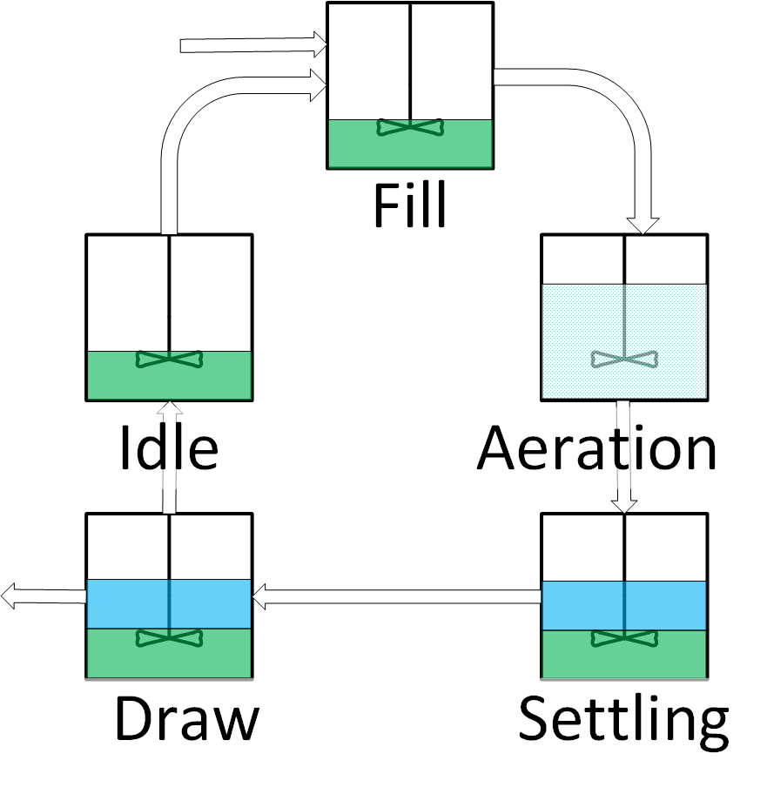Accumulating Organisms (PAO), denitrifying phosphate accumulating organisms (DPAO), nitrifying and denitrifying bacteria without carbon source competition[9].

Figure .: Sequencing Batch Reactor schematic

There are some several drawbacks as SBBR are prone to clogging[10]. There is also the potential of floating or settled sludge in the effluent as there is no clarifier unit in the design[11].

### 2.1.3 Membrane Bioreactors

Membrane bioreactors (MBR) are likely the most popular bioreactors that have attracted a large amount of research. MBRs are recognized as the replacement of the secondary clarifier of the conventional activated sludge process with membrane filtration[12]. MBRs are an attractive option for retrofitting conventional plants due to its small footprint and high quality effluent[13].

One of the main advantages of the MBR over Conventional Activated Sludge (CAS) process is a higher concentration of slowly growing microbes[14]. This is particularly as nitrifying bacteria exhibit this behaviour.

The best phosphorous removal performance comes from incorporating MBR in hybrid configurations. Membranes utilized well established Biological Nutrient Removal systems, such as the University of Cape Town, have been shown to have phosphorous removal rates of 88%[15] and 87%[16]. Without this additional consideration, the phosphorous removal for MBR can be quite low at 53%[17]. Bracklow preformed a series of four different recirculation schemes with different arrangements of three stage reactors (anaerobic\anoxic\aerobic) and found that there was insignificant differences in nutrient removal rates between schemes. The average removal rates were 97% COD, 88% nitrogen and 99% phosphorous[18].

Membrane aerated biofilm reactors (MABR) are more complicated technology than MBR. Rather than using the membrane for separation, the membrane itself becomes the site of biological growth. Pressurized air flows on one side of the membrane while water flows co-current on the other side (Figure 2.3). A biofilm than develops on the surface of the membrane. There are significant increase in aeration rates with a MABR when compared to bubble aeration all in a smaller tank size[19]. Through careful control of the dissolved oxygen levels, both nitrifying and denitrifying kinetics can take place in a single stage[20]. MABR have also been shown to have a significant power reduction of up to 86% when compared to CAS mainly due to the efficiencies for aeration[21].

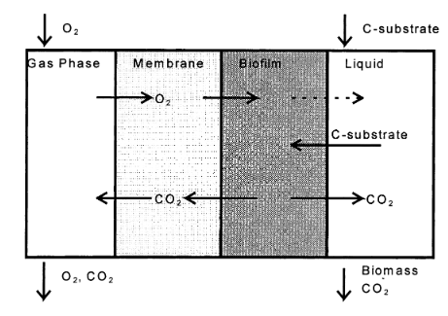

Figure .: Membrane Aerated Biofilm Reactor[8]

The main difficulty with membranes are their high costs. Their expense comes from two sources, a high initial cost of the modules ($50 US/m2 as of 2005[22]) and high maintenance costs. The high maintenance cost comes from the energy demand to deal with membrane fouling. Even after a decade of research and extensive reviews([23]–[25]), there is no consensus on membrane fouling. A lack of standardized fouling characterization method has led to results that sometimes conflict.

### 2.1.4 Algae-based technologies

The application of algae cultures for wastewater treatment has become a developed technology ([26], [27]) but it has not been applied at the pilot and full-scale. The mechanism of phosphorous removal by algae is illustrated in Figure 2.4. Algae cells reach a saturated stage of phosphorous uptake at about 3% phosphorous by dry weight with a critical minimal level of 1%[28]. Algal treatment can take place in a variety of techniques as a suspended solution or as a biofilm. A system using a microporous tissue for cell immobilization has been shown to remove 90% of phosphorous and 69-78% nitrogen[27]. Algal growth can even be incorporated in Membrane Bioreactors (MBR) for increased effluent efficiencies(92% nitrogen and 91% phosphorous removal)[29].

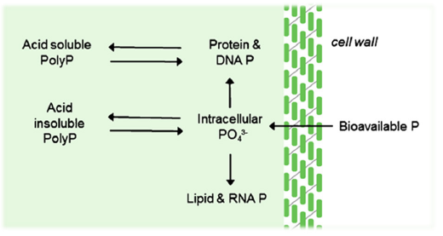 There are some disadvantages to this technology. Algae growth is highly dependent on temperature and exposure to light. This creates a large challenge for locations with conditions of lower seasonal temperatures and sun exposure present at higher latitudes. Algae-based systems is still a technology in its infancy, there lacks research on long term studies and at different flow regimes[30]. The technology has still attracted research despite these deficiencies.

Figure .: Mechanism of Algal Phosphorous Removal[4]

## 2.2 Biological Nutrient Removal

Biological Nutrient Removal (BNR) is an increasingly important field of research. Regulations regarding the concentrations of nutrients in the wastewater industry has become more stringent with chemical or biological treatments available. Biological treatments are the more economical and effective solution to chemical treatments [31].

The two nutrients in wastewater are nitrogen and phosphorous compounds. Poor nutrient treatment can lead to environmental catastrophes including eutrophication. Eutrophication is caused by the over stimulation of algae growth due to the higher concentrations of nutrients. This higher concentration of algae eventually decomposes creating layers of decaying material on the bottom of the body of water. High Algae concentration have now changed the body of water to a dark green colour. The increased decomposition has released hydrogen sulfide compounds producing an unpleasant odour. This darkening of the water, decreases that mass transfer of oxygen into the water. The initial wildlife response can be deceptive with increased fish populations from the increased food source. The increase in microbial activity and the decrease in mass transfer reduces the concentration of dissolved oxygen. Fish can no longer obtain the oxygen they require for respiration, increasing the amount of decaying material.

Phosphorous and nitrogen play two different roles in microbiological life and as such require two distinct sets of reaction kinetics.

### 2.2.1 Biological Nitrogen Removal

Traditional nitrogen-compound removal has been treated as a three-stage process: Hydrolysis and Ammonification, Nitrification and Denitrification (Figure 2.5). The first two processes take place under aerobic conditions (presence of dissolved oxygen) while the Denitrification step takes place under anoxic conditions (no dissolved oxygen but the presence of other dissolved oxygen compounds). Hydrolysis and Ammonification is the process for the conversion of particulate organic nitrogen into soluble ammonia. Ammonia is then oxidized by nitrosomonas and nitrobacter bacteria into nitrites and nitrates respectively. Heterotrophic bacteria can than reduce nitrates into nitrogen gas[32].

This is a simplified model of the biological nitrogen removal process that does not well represent current developments in the field([33], [34]) but it should be sufficient for the understanding of the operating conditions and principles of BNR processes.

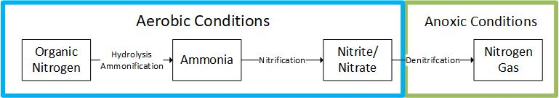

Figure .: Biological Nitrogen Removal Flow Chart

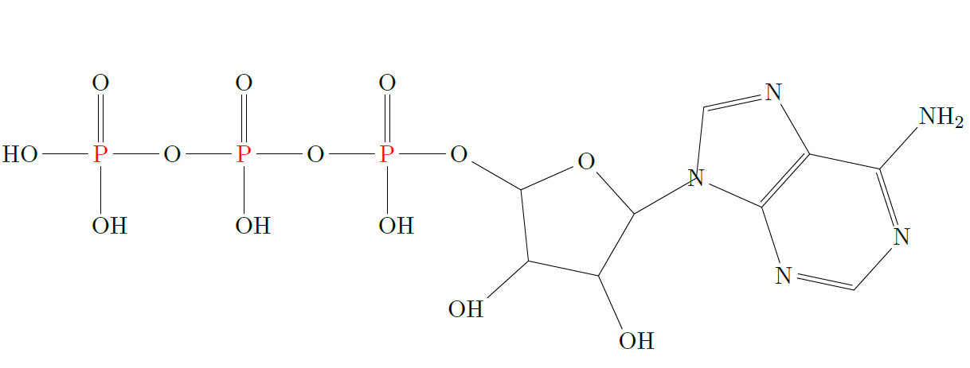

Figure .: Skeletal Structure of ATP

### 2.2.2 Biological Phosphorous Removal

The main biological role of phosphorous is facilitating the storage of energy. Cells including microbes use a compound called Adenosine Triphosphate (ATP). The skeletal structure can be found in Figure 2.6. The phosphorous bonds require a large amount of energy to form and likewise releases a lot when broken. When ATP under goes hydrolysis into Adenosine Diphosphate (ADP), the reaction releases 7.4kcal/mole.[35] ADP still has two more phosphorous bonds, which can further hydrolyze releasing more energy.

All heterotrophic bacteria in the activated sludge utilize phosphorous but at relatively low concentrations (0.02 mgP/mgVSS) with a removal rate about 15-25%. Additional phosphorous removal requires selecting for Phosphorous Accumulating Organisms (PAOs). PAOs have a higher utilization rate of phosphorous (0.38mgP/mgVSS) but - evolutionary speaking - they are non-competitive[36]. In the wild frenzy of the activated sludge microbiome, storing energy is not a good strategy. Microbes that utilize energy to grow or to divide will quickly outnumber microbes that store energy. It is because of this non-competitive nature of PAOs that operating conditions must be optimized for their selection.

In the anaerobic stage (Figure 2.7), PAOs uptake volatile fatty acids (VFA) to create long carbon chains called polyhyrdoyalkanoates (PHA). The cells use their internal energy by breaking

Phosphorous bonds which releases phosphorous in the wastewater. Thus the PAOs absorb VFA which other heterotrophic bacteria are incapable to[36].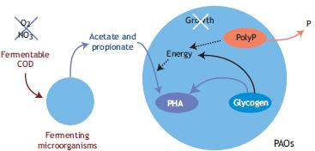

Figure . Biochemical model for PAOs under anaerobic conditions[10]

In the aerobic stage (Figure 2.8), PAOs digest the newly formed PHA with the dissolved oxygen playing the role of an electron acceptor. This digestion releases energy for the cell, which it can use for cell growth. The excess energy is stored in the form of poly-phosphates (such as ADP and ATP) which facilitates phosphorous transfer from the wastewater into the cell. Phosphorous is than fully removed from the BNR reactor as it is trapped in wasted sludge[36].

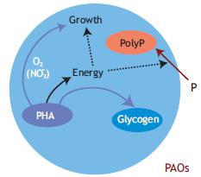

Figure .: Biochemical model for PAOs under aerobic conditions[10]

Organisms in the Acinetobacter group have been widely considered as the ideal PAO population[37] but recently Nguyen has found that Tetrasphaera bacteria in many different Enhanced Biological Phosphorous Removal (EBPR) plants. This is of interest as Tetrasphaera exhibit a more flexible substrate uptake[38]. Through a gene study, it was confirmed that Tetrasphaera is capable of denitrification[39]. These are important developments as they can change the model of EBPR and affect the design of Biological Nutrient Removal (BNR) treatment plants in the future.

### 2.2.3 Activated Sludge Models

The microbial kinetics of wastewater treatment processes have been a field of study for many years and the most influential model is the Activated Sludge Model (ASM). The initial ASM model was limited as it only pertained to the removal of the carbon components. It did however introduce the matrix model, which simplifies the expression of the series of different microbial reactions taking place. A sample of the matrix can be found in Table 1. A mass balance for each component j can be constructed by following a column for the specific component. Each column will contain coefficients need to be multiplied by the process rate ρj (ML-3T-1) at the end of the row. The mass balance is than the summation of the product of the coefficients and process rates. This is a significant development as it organizes the reactions where each column represents the mass balance for a component and each row represents a specific reaction rate. Organization is required as more development into the field increases the number of reactions and number of substrates which become difficult to follow.

The different reactions are based on the Monod equation, which is defined as:

(2.1)

Where μ is the growth rate (t-1), μmax is the max growth rate (t-1), S is the substrate concentration (M/L-3) and KS is the half-velocity constant (M/L-3).

The development in activated sludge models required the addition of nitrogen and phosphorus removal kinetics which were included in the ASM2D model[40]. An increased level of complexity accompanies additional reaction kinetics. As an example, the Activated Sludge Model for Nitrogen (ASMN) models 3 different groups of microbes, 18 biological processes, 20 components and contains 54 parameters in total[33]. The ASMN includes provides significant advances such as the activities of ammonia-oxidizing bacteria (AOB). This creates a model that is more robust and can more accurately model Biological Nutrient Removal processes.

|  |  |  |  |  |
| --- | --- | --- | --- | --- |
| Component →j | 1  X­B | 2  S­S | 3  S­O | Process Rate,  ρj (ML-3T-1) |
| Process ↓i |
| Growth | 1 |  |  |  |
| Decay | -1 |  | -1 | bXB |
| Observed Conversion Rates  (ML-3T-1) |  | | |  |
| Stoichiometric Parameters:  True growth yield: Y | Biomass  (ML-3) | Substrate  (ML-3) | Oxygen  (ML-3) | Kinetic Parameters:  Maximum Specific growth rate: μ (T-1)  Half-velocity constant:  KS (ML-3)  Specific decay rate: b (T-1) |

Table : Activated Sludge Model (ASM) Table

## 2.3 The Residence Time Distribution

### 2.3.1 Definition

Continuous flow systems are categorized into two simplified models, the Plug Flow Reactor (PFR) and the Continuous Stirred Tank Reactor (CSTR). The CSTR model requires the assumption of perfect mixing throughout the reactor while the PFR model requires the assumption that elements of fluid flow into the reactor travels in parallel paths and they leave at the same moment. In reality, most reactors do not well represent either of these cases very well. The assumptions are made however to significantly reduce the complexity of a system. Danckwerts[41] and Zweitering[42] developed a technique to better understand the behavior of flow with the Residence Time Distribution (RTD). This incredible development as it represents a diagnostic tool that accurately describes the true mixing profile.

The technique requires the introduction of a traceable element into the continuous flow reactor. The traceable element is then measured as it exits with a sensor that is specific to the parameter that the element is traceable by. For more information on the process of tracer selection, please refer Section 3.1.1 Tracer Selection. A C-diagram can be created by plotting the concentration of the tracer at the exit versus time. The first RTD function , the Population Density Function (E (t)), can then be obtained from dividing the concentration of the tracer by the area under the C-diagram (equation 2.2). The area under the C-diagram (or the integral) represents that mass of the tracer injected into the system[43]. The E (t) function represents the probability of the tracer exiting the system at time t when excited by a single pulse.

(2.2)

The second RTD function is the Distribution Function (F (t)). The F (t) function represents the fraction of tracer that has exited the reactor at any time. It represents the cumulative sum of the E (t) and thus can be represented by the following equation. It also represents the system response to a step change. A pulse is a quick (as close to instantaneous as possible) injection of a set volume of tracer while a step change is the continuous injection of a tracer for the duration of the experiment

(2.3)

### 2.3.2 Application of RTD Measurements

The main applications for RTD measurements, as outlined by Missen, are the following[44]:

1. As a diagnostic tool for the detecting and characterizing flow behavior
2. The estimation of values of parameters for non-ideal flow models
3. The assessment of performance of a vessel as a reactor

The graphs that represent the RTD functions for a reactor are important tools in identifying issues with the mixing. One such example was when Goswami found the RTD for a constructed wetland described a dead space in the reactor to be between 0% and 41% of the entire volume[45]. The theoretical residence time, measured by the volume of the reactor divided by the fluid volumetric flow rate, was found to be larger than the experimentally observed mean residence time. This suggests that the tracer did not travel throughout the entire volume. The volume of which the tracer did not travel through is referred as the dead space because no reaction would take place there.

The simplest application is comparing the reactors RTD to that of the ideal graphs represented in Figure 2.14 & Figure 2.16. It can provide as quick and simple visualization of the discrepancy from the ideal conditions.

The true value of the RTD experiment comes from the creation of the parameters for the non-ideal flow models. Non-ideal flow models seek to represent the flow of real reactors. These models rely on the fact that every flow model has a unique RTD but not every RTD has a unique flow model. "Real reactor" models are the generated and their RTD calculated. These models are than compared to the experimentally collected results. If the RTD that describes the non-ideal model also fits the experimental data then the non-ideal model also fits flow dynamics of the reactor.

The final application of the RTD is the assessment of the reactors performance. This assessment relies on three factors:

* Whether the fluid behaves as a segregated or a maximum mixedness fluid
* When mixing occurs
* The overall reaction order.

A first order reaction is expressed as the following:

Where ra (M/s) represents the reaction rate, k (1/s) the rate constant and Ca (M/l) the concentration of component A. In this instance, only the RTD effects the conversion as the reaction takes place with a single molecule and doesn’t require any collision. For reactions of any other order, the RTD data are not enough[42].

A segregated fluid enters as globules with perfect mixing within each globule but no mixing between them. This is also referred to as a macro-fluid. A micro-fluid, or a maximum mixedness fluid, has the opposite behaviour where each element is free to mix fully throughout the system (Figure 2.9).

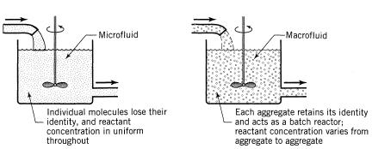

Figure .: Micro vs Macro Mixing[18]

|  |  |
| --- | --- |
| Reaction Order | Conversion |
| n < 0 |  |
| 0 < n < 1 |  |
| n = 1 |  |
| n > 1 |  |

Table : Micro-mixing effect on conversion by reaction order[3]

The conversion rates for a reaction of order n can vary depending on whether the fluid behaves as a micro-fluid or as a macro-fluid as describes in Table 2 [46]. The proof for these relationships is quite complicated as they require modeling both systems and integrating them for a reaction of nth order. The derived model equations can be found in literature[3]. It is also important to note that wastewater treatment reactions are often of mixed order, between first and zero[47]. There is no effect on the conversion in a PFR due to the degree of segregation as a PFR can be considered as a flow of batch reactors with the same residence time.

The effect of when the mixing happens was first explored by Zwietering[42]. The simplest way to explain it is illustrating a CSTR and a PFR in series (**Error! Reference source not found.**). No matter the order of the reactors, the overall RTD will be the same. Both systems will have the same overall mixing profile. The second case, where the CSTR proceeds the PFR, mixes much sooner than the alternative. If the reaction rate depends on the mixing than the earliness or lateness of mixing will affect the overall conversion.

In reactors with a single reaction, the effects of segregation and earliness of mixing can usually be ignored. For reactors with multiple reactions, such as the vertical bioreactor for the treatment of wastewater, these effects can become more prominent.

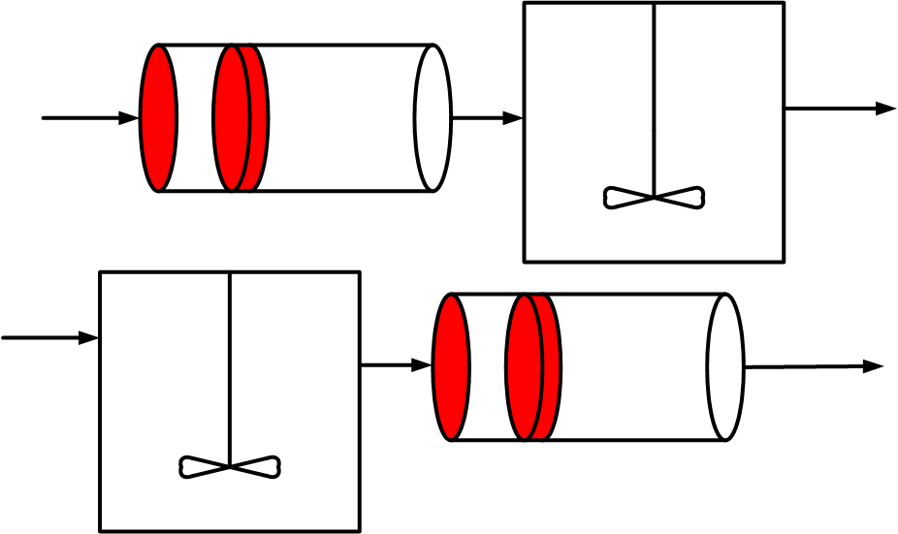

Figure .: Demonstration of early vs late mixing

### 2.3.3 Dead space and By-passing

Dead space and By-passing are two undesirable conditions in a reactor as they represent deviations in the Mean Residence Time (MRT). Dead space is an area stagnation with undesirable reactions. By-passing refers to the formation of channels through the reactor were reagents do not mix and are not utilized for the reaction. Both represent inefficiencies in the mixing profile.

These conditions are understood by modeling them[46]. For the definition of the Mean Residence Time, where MRT is represented by τ (T), volume as V (L3) and flow rate as v (L3T-1):

For a reactor exhibiting the condition of by-pass, the portion that is by-passed can be modelled as split stream from the main fluid flow that does not enter the reactor. The overall flow rate (v0) (L3T-1) is the summation of the flow that enters (vE) (L3T-1) and the flow that by-passes (vB) (L3T-1) :

Where the observed residence time, τobs (T), is:

And then comparing the ratio of the two MRTs:

From the last line, it is apparent that a model with by-passing will have an observed MRT higher than average.

For a system with Dead space, part of the volume does not take part in the reaction. The overall volume (V) (L3) is the summation of the dead space (VD) (L3) and the active volume (VA) (L3).

Where the new observed MRT is:

And then comparing the ratio of the two MRTs:

The last line shows that for a reactor with dead space, the observed MRT will be smaller. As a summary, the following has been shown:

### 2.3.4 Hold-back and Segregation

Danckwerts had described two additional quantities of interest to describe the RTD: The Hold-back (H) and the Segregation (S)[41]. These quantities are related and both are observed from the Distribution Function (F (t)).

The Hold-back represents the fraction of fluid that spends more time in a reactor than average. It is defined by the following equation where θ is the dimensionless time found by dividing time t (T) by the mean residence time τ (T):

(2.3)

This quantity is represented as the area under the curve (Figure 2.11) of the dimensionless F (t) between θ = 0 and θ = 1. The two values of the shaded areas are the same due to the symmetry (both labled as A). The value of H will vary from 0 for plug-flow conditions to 1 for total dead space. The value for H will be e-1 ( ≈ 0.3679) for the ideal CSTR.

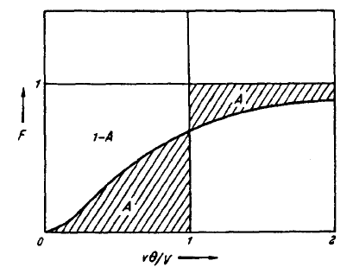

Figure .: Hold-Back

The quantity of segregation (S) on the other hand, represents the deviation from perfect mixing from a CSTR. The value is found from superimposing the plot of F (θ) with that of the ideal CSTR which is F (θ) = 1 – e-θ (Figure 2.12). There is a second case which represents a reactor with dead space were the reactor F (t) precedes the ideal CSTR F (t) (Figure 2.13). This provides another test for the presence of dead space. The two shaded areas again represent the same value due to the symmetry (labeled A1 in both Figure 2.12 and Figure 2.13). To show that is represents a deviation from the ideal conditions; the value is taken to be as negative. The quantity varies from e-1 for plug-flow to -1 for entirely dead space.

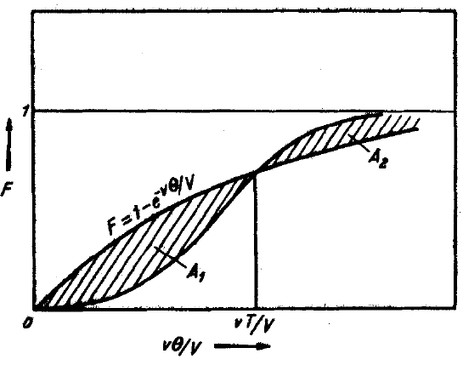

Figure .: Segregation quantity (S)

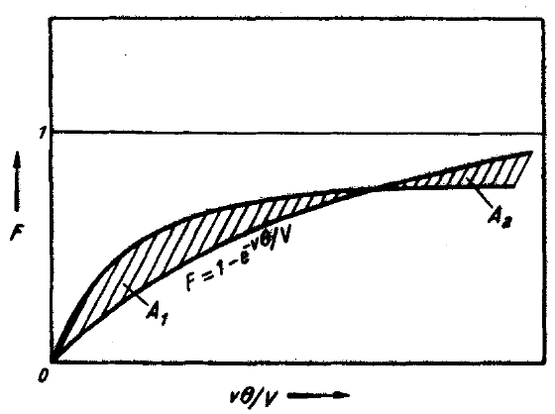

Figure 2.13: Segregation quantity (S) with dead space

## 2.4 Ideal Models

The first step to modeling the behavior of idealized flow is utilizing the first principles of chemical engineering and performing a mass balance across the reactor. This procedure was outlined by Salmi[43]. Performing the Macroscopic Molar balance for the system obtains:

|  |  |
| --- | --- |
| [accumulation] = [flow in] [flow out] + [generation] | (2.4) |

Alternatively, it can be represented mathematically as:

(2.5)

Where (molT-1) represents the accumulation/consumption of component i in the reactor ((mol)) represents the net change in the molar flow rate of component i entering and exiting the reactor, V (L-3) represents the volume of the reactor and

(molL-3T-1) represents the sum of all reactions. The molar amount can be represented as concentration by the definition of molar concentration.

(2.6)

(2.7)

Substituting equation (2.7) into equation (2.5) to obtain:

(2.8)

Equation (2.8) can be simplified with the assumption of a constant reactor volume, V (L3), and constant flow rate, (L3T-1), to become:

(2.9)

Dividing both sides by the flow rate v (L3T-1):

(2.10)

Utilizing the following definition of the mean residence time (τ) (T):

(2.11)

In addition, substituting it back into equation (2.9):

(2.12)

### 2.4.1 Continuous Stirred Tank Reactor

To find the response of a CSTR to a tracer injection, we can first simplify the mass balance in equation (2.10) by recognizing that for a tracer there is no reaction term. The equation can be further simplified due to no initial concentration of the tracer in the reactor at time t = 0.

(2.13)

The model is describe by a first order differential equation. Rearranging the equation integrating for the initial boundary condition becomes: .

(2.14)

Where the concentration at any time can then be represented by the following:

(2.15)

Now that the C (t) function for a CSTR has been found, equation (2.2) can be utilized to find the E (t) function.

(2.16)

Solving the integral in denominator and evaluating it at the points t=∞ to t=0.

(2.17)

Substituting the integral back into equation (2.16):

(2.18)

This idealized behavior is represented in Figure (2.12). The sample mean () (T) of the probability function E (t) can be expressed as:

(2.19)

Substituting the value for the probability function for the ideal CSTR as described in equation (2.18):

(2.20)

This proves for the case of the ideal CSTR, the sample mean residence time is equal to the mean residence time. The general equation for the standard deviation (σ) of a function is expressed as:

(2.21)

Where represents the mean or average of a function, f (t) represents the function value at time (t) and E (t) represents the distribution function or the probability function. For the special case of the ideal CSTR probability function:

(2.22)

The distinction between , τ and t can easily become confusing. () represents the average sampling time from a discreet series of samples. (τ) represents the mean residence time as part of a continuous function. (t) is the time scale of which samples or continuous functions are measured on.

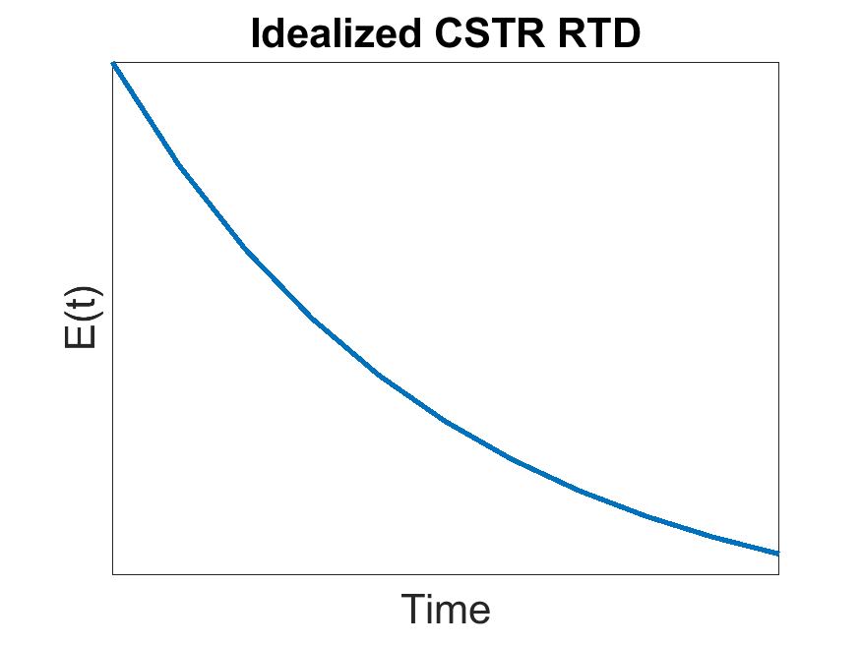

Figure .: E-Diagram of Ideal CSTR flow

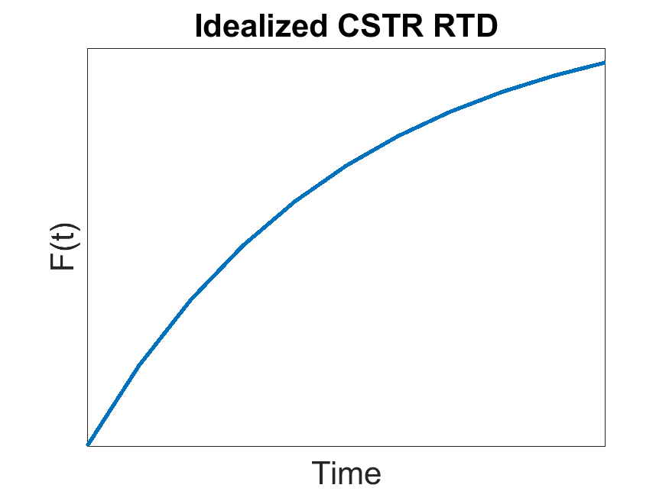**This shows that the standard deviation for a CSTR is equal to the residence time. This implies that no distribution can be broader than the ideal CSTR.

Figure .: F-Diagram of Ideal CSTR flow

The final step is the calculation of the Distribution Function which again can be calculated from the E (t) and equation (2.2). The values for the Ideal CSTR are displayed in Figure 2.14 and Figure 2.15 respectively.

### 2.4.2 Plug Flow

For the idealized case of Plug Flow Reactor, you could obtained the response to a pulse by solving the transient PFR equation in a similar fashion as the CSTR but the solution can be simply obtained by following the pulse down the reactor length.[48] The δ(0) function moves down the length of the reactor without broadening because of the assumption of perfect plug flow behavior in which no mixing takes place. The tracer then travels the full length of the reactor and exits at the mean residence time, which can be simply expressed as the length of the reactor divided by the velocity of the fluid as explained in equation (2.11). Since no change in behaviour from injection, the RTD can be represented by the same function from the injection (the δ(0) function).

(2.23)

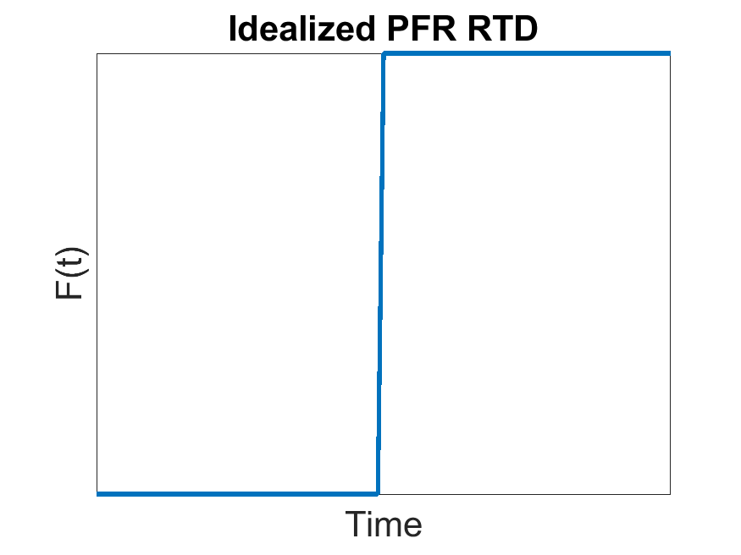

Figure .: F-Diagram of Ideal PFR flow

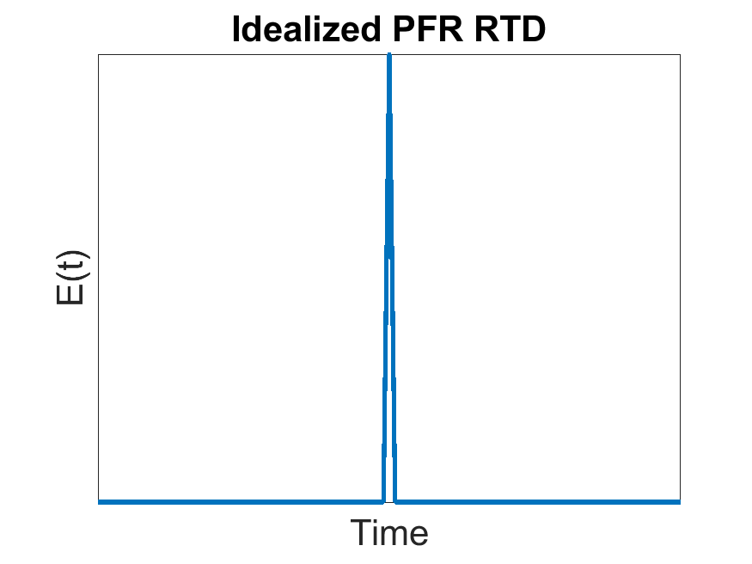

Figure .: E-Diagram of Ideal PFR flow

The standard deviation for a PFR can then be calculated from equation (2.21) but again since there is no mixing it is easy to understand that the following is true:

(2.24)

## 2.5 Real Reactor Models

Real Reactor Models are mathematically generated equations used to fit Residence Time Distribution curves. In this way, we can test different model parameters against the true behaviour of a reactor. The simplest of Real Reactor models are the single parameter models, which include the CSTR in series, and the axial-diffusion models (referred to as axial-dispersion models). More complicated models exist but their usefulness has diminishing returns as they become more complex with additional parameters.

### 2.5.1 CSTR in Series

The CSTR in series, also referred to as the tank in series model, models the flow from one CSTR to another for a set number of CSTRs (Figure 2.18). These individual CSTRs are modeled by the ideal CSTR with identical reactor volumes. With an increase in the number of CSTR in series from one to infinity, the flow behaviour deviates from the ideal CSTR to the ideal PFR. This variation in the flow dynamic profile provides a great flexibility to the system. The algorithm is based on the following equations:

(2.25)

Figure 2.19 shows the effect that changing the design parameter N, the number of CSTRs in a series, has on the RTD. A Matlab code was created that employs the algorithm along with a vector of different values or N (From 1 to 20). This model has been compared to different tracer experiments.

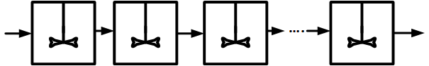

Figure .: CSTR in series Schematic

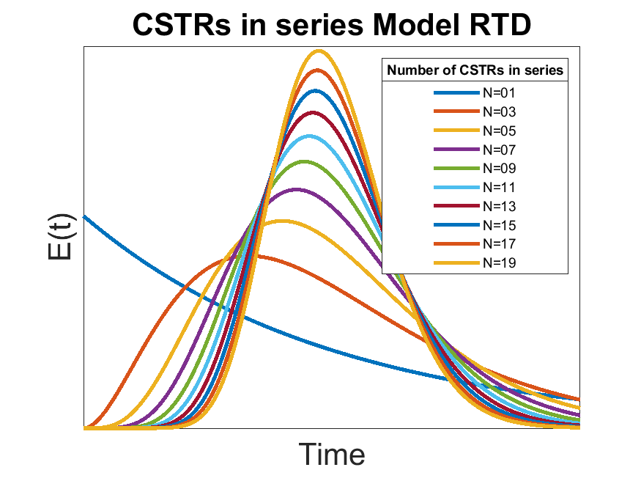

Figure .: RTD for CSTRs in series for different number of CSTRS

### 2.5.2 Axial Dispersion Model

The Axial Dispersion model starts with the foundation of the PFR but adds a degree of backmixing. The magnitude of the backmixing is independent of the position within the reactor. The concentration profile can be described by the following second order differential:

(2.26)

represents the dimensionless dispersion coefficient, z (m) the direction of flow and C (M/L) as the tracer concentration.

The following equation describes the RTD for small levels of dispersion. This is a simplification and not a full solution to the differential. It should be noted that the equation that is within 5% accuracy when < 0:01[3].

(2.27)

As the model has a second order differential, it requires two boundary conditions to solve. The boundaries are taken as the inlet and outlet of the reactor. Each boundary can either be considered open or closed (Figure 2.21). Open signifies undisturbed dispersion as it passes the boundary while closed signifies plug flow outside of the boundary. The two situations of greatest

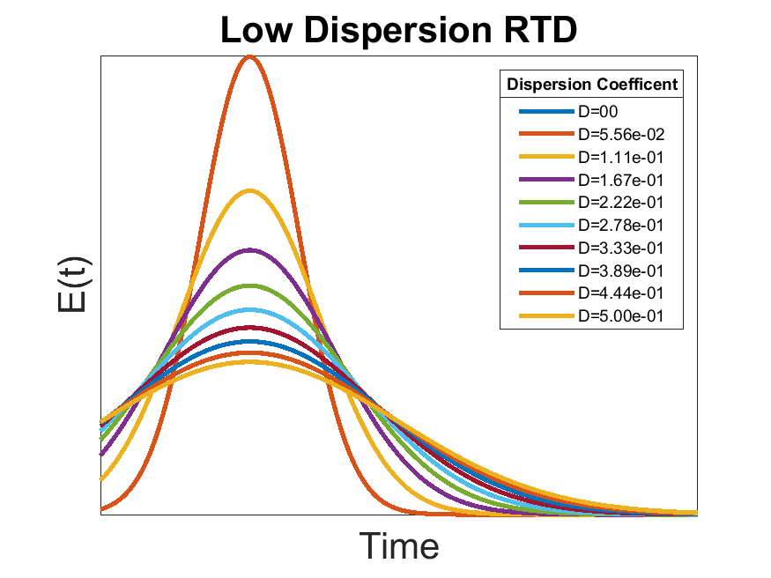

Figure .: RTD for Small Dispersion

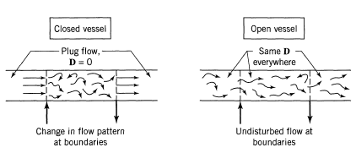

Figure .: Axial Dispersion Boundary Conditions[3]

interest are the open vessel (open/open) and the closed vessel (closed/closed). The closed vessel condition cannot be solved analytically but it can be solved numerically. The open vessel can be described by the following equation and Figure 2.22:

(2.28)

The difference observed from going from the low dispersion model to the open dispersion model is a shift to the left with a longer tail. The low dispersion model exhibits symmetry across the time axis. The solutions have been published for the boundary conditions open/closed and closed/open.[49]

### 2.5.3 Enhanced CSTR in series

The Enhanced CSTR in series model is based on the original model but it includes two additional parameters[50]. The model represents a series of CSTRs in series in which a portion (1-n) will bypass the specific CSTR (Figure 2.23). This variable ranges in value from 0-1 where n = 1 is 100% likely to enter the CSTR. The probability for bypass is equal for each CSTR in series. The second parameter M represents the opportunity for dead space within each CSTR. Just as in the previous parameter, the probability is the same at each CSTR and the range is from 0 to 1. These additional parameters significantly increase the complexity of the model. To solve this model a grid needs to be created. The model is described by the following equation:

(2.29)

The model equation is not very programming friendly. The summation term requires the use of a for loop in Matlab which prevents the function from becoming 100% vectorized. This will significantly increase the required computational time for simulation. The application of a four dimensional grid also requires a lot of system memory reducing the resolution for the parameters while also increasing the computational time.

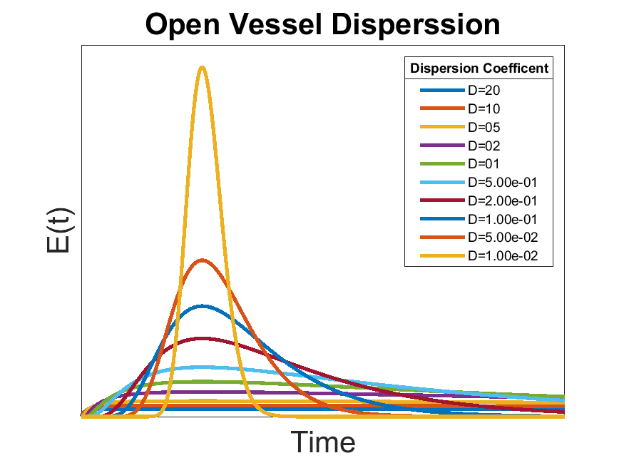

Figure .: RTD for Open Vessel Dispersion

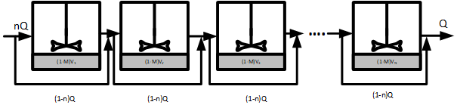

Figure .: ECSTR Schematic

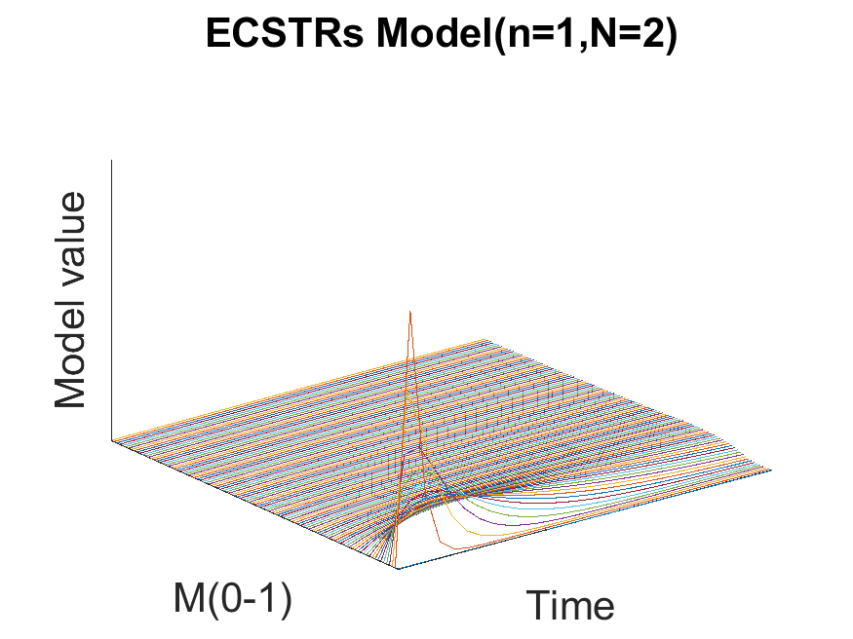

Figure .: Enhanced CSTR in series effect of M

### 2.5.4 n-CSTR Model

One of the major limitations of the CSTR in series model is the reliance on the factorial of (n-1). This term limits the application of this model to natural numbers of n. Martin overcame this obstacle with the application of the Gamma function ()[51][52]. Refer to Appendix 1: Gamma function for more information on the Gamma Function.

There are two advantages to this modification: the representation of value between real numbers (such as values between 1 and 2 when neither of them quite fit well), and the representation of systems with by-passing were N < 1.

Figure 2.26 outlines the different Residence Time Distribution functions for different values of N using the n-CSTR Model. The n-CSTR Model (also referred as the Extension to Tank in Series (ETIS))

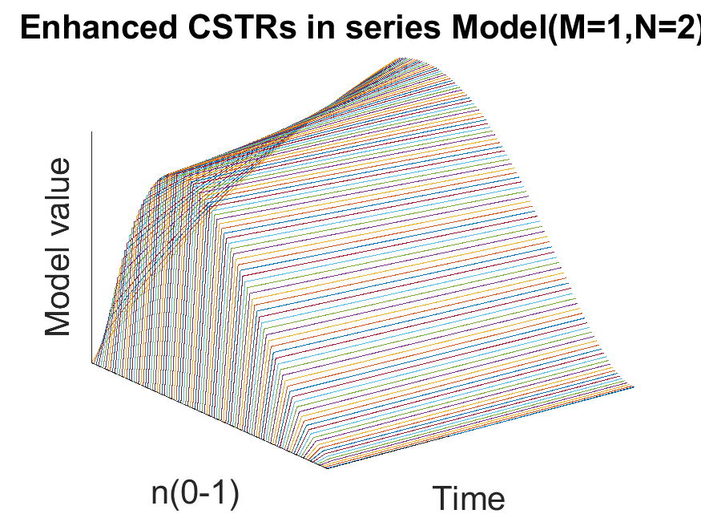

Figure .: Enhanced CSTR in series effect of n

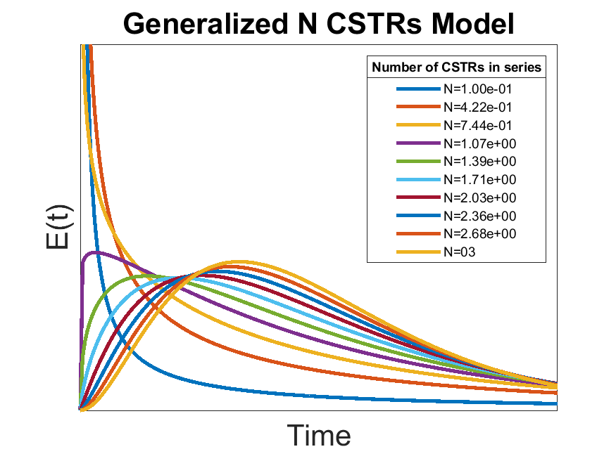

Figure .: RTD for n-CSTR Model at different number of CSTRS

approaches the PFR when the value of Similarly, the model is equalto the ideal CSTR when N = 1. The unique behaviour of this model allows the demonstration of the two extreme ideal models along with a model exhibiting bypassing when 0 < N < 1.

## 2.6 Computational Fluid Dynamics

There have been many interesting developments in the area of Computational Fluid Dynamics (CFD) over the last decade. CFD models have the potential to meet some of limitations of RTD. The RTD can provide insight on dead space and by-pass channeling but it does not provide any dimensional information. The basis of CFDs is the simulation of the Navier-Stokes equation extended over the three dimensions of the reactor. Research has shown that a CFD can develop a series of steady moment transport equation to derive the moments of the RTD without the need for a tracer experiment[53] CFDs are not a perfect solution, there are still parameters that need to be evaluated such as: approach, discretization scheme and turbulence model[54].

# : Materials and Methods

## 3.1 Construction of the STAR reactor

The original STAR reactor, developed by Dr. Maryam Reza and Dr. Manuel Alvarez Cuenca in 2016[2], was deconstructed with some of the parts used for the study of an alternative reactor in another study. The components of the STAR reactor required reassembly following the process flow diagram outlined in Figure 3.1.

### 3.1.1 Tracer Selection

It is important that the tracer selected acts as a good representation of the fluid flow, thus the tracer selection process is paramount. It is important that the tracer exhibits the following characteristics[44]:

1. The tracer should be stable and conserved
2. The analysis for the tracer should be convenient, sensitive, and reproducible
3. The tracer should be inexpensive
4. The tracer should not be absorbed on or react with the surface of the vessel
5. The tracer should be chemically and physically similar to the fluid flow

Traditionally the tracer has been nonreactive but a decaying tracer can be corrected for.[49] There has been research in the use of reactive tracers for long term model monitoring; however, it doesn’t allow for the determination of the RTD.[47] The benefit of a reactive tracer is that a process reagent can act as the reactive tracer so no additional work is required.

Missen suggests the following additional precautions when performing a tracer experiment[44].

* Inject properly: If the velocity profile at vessel inlet is at, introduce tracer uniformly across the cross section. If it is not at, introduce tracer proportional to the flow rate.
* Measure properly: Average over all flow rates. This is called the mixing cup measurement.

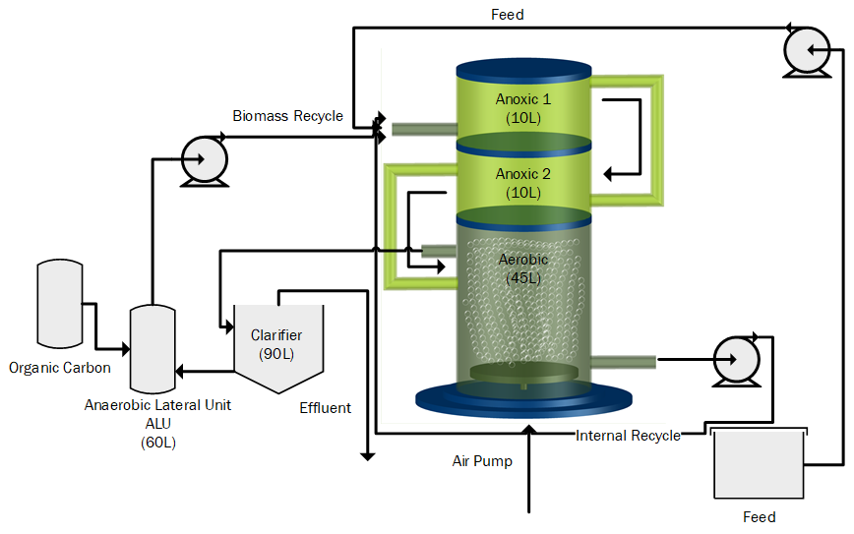

Figure .: STAR Vertical Bioreactor: Process Flow[6]

Through the field of water engineering, many different tracers are available. Some of the different possible tracer technologies are summarized in Table 3. The tracer criteria are summarized in Table 4.

|  |  |
| --- | --- |
| Method | Principle |
|  |  |
| Conductivity | Electrical Conductivity |
| Photometry | Light absorbance (visible or ultra-violent) |
| Mass Spectroscopy | Different mass numbers of components |
| Para-magnetic Analysis | Para-magnetic properties of compounds |
| Radioactivity | Radioactive radiation |
| Gas Chromatography | Adsorption of a compound on a carrier material |
| Liquid Chromatography | Adsorption of a compound on a carrier material |
|  |  |

Table : Common analytical methods for tracer experiments[43]

After the type of tracer has been selected, it is important to select what type of signal you would like to simulate. The first and simplest signal is the Dirac Signal (δ) also known as a pulse signal. This signal requires the injection of a single volume of injectable material at time t = 0 with the concentration of C0. It has the major advantage that it only requires a small amount of tracer. It also has a small impact on the process operation. Some trade-offs exist as it can be difficult to produce the perfect pulse. The full amount of the tracer needs to be injected at an instance. It can also make it di cult to perform a mass balance for the tracer.[44]

In some cases, a step input is preferred where a set constant flow rate of tracer is continuously added to the system. This can be performed by a "step up" or a "step down" in tracer concentration. This creates a system that is easier to perform a mass balance for as well as being easier to achieve. The opposite of the pulse function is also true. It requires much more tracer element and it is more likely to affect process operation[44].

A periodic signal or a random signal can also be used; however, these signals are much more complicated to generate then a step or a pulse. The random or periodic signals are also more difficult to interpret. The pulse method was selected due to the simplicity and minimal requirement for tracer.

There have been some interesting developments in the application of alternative tracers. Ahnert studied storm water events with cold water as a tracer signal for a Waste Water Treatment Plant (WWTP)[55]. This would be a very simple and cost-efficient method for performing tracer experiments. Reactive tracers are another potential avenue such as the experiments performed by Braun[56]. The WWTP under study experiences fluctuations of ammonia and oxygen concentrations at night due to an unresolved issue in the process. Braun was able to use these fluctuations as a randomly generated tracer signal. The disadvantages of a reactive tracer include uncertainty of the measurement device and a lower detection limit.[57]

A solution of sodium chloride was selected as a tracer. It is frequently used in industry as it behaves similarly to wastewater. The tracer is also very cheap and easy to obtain. The tracer however can not be used for wastewater - it will be absorbed by microbes - but it is appropriate for clean water. Very little system modifications would be required to experiment with wastewater and a Lithium Chloride tracer. Lithium Chloride has the advantage of low absorption rates in the activated sludge. There are some concerns about the toxic effect of Lithium Chloride on aquatic life including effects on algae and minnow larvae[58].

### 3.1.2 Sensor Selection

The measurement of conductivity is not 100% standardized. There are a few different measurements but one of the most common ones is the Micro Siemen per centimeter (μS/cm). Often the /cm is omitted. It was determined that the maximum range required for saturated sodium chloride solution would be about 10,000 μS/cm[59]. A saturated solution of Lithium chloride was found to be only slightly higher.

|  |  |  |  |  |
| --- | --- | --- | --- | --- |
| Technology | Criteria | | | |
|  | Price | Sensitivity | Industrial Application | Operation |
| Conductivity | Cheap | Wide | Common[47], [50], [56], [60]–[63] | Continuous |
| Photometry | Cheap | Wide | Common[61], [64]–[66] | Continuous |
| Mass Spectroscopy | Expensive | Wide | Common | Discontinuous |
| Para-magnetic | Cheap | Wide | Common | Continuous |
| Radioactive | Expensive | Wide | Uncommon[45] | Continuous |
| Chromatography | Expensive | Wide | Uncommon | Discontinuous |

Table : Tracer Technologies Criteria

The CDCE-90-1 conductivity cell was chosen for this experiment as it was provided by a recommended supplier and it was capable of covering the required conductivity range (10-10000 μS/cm). The range available for a cell is dependent on the cell constant. A higher cell constant has a higher range but it will be less sensitive on the lower limit. The CDCE-90-1 was able to handle the highest conductivity reading of the saturated tracer solution and the lowest possible value as the conductivity of tap water, which is ≈ 300 μS/cm.

### 3.1.3 Sensor Placement

One of the largest tasks in assembling the tracer experiment was deciding how the sensors would fit into the reactor. The current sensors are submersed in the reactor, attached through the walls. This would not be acceptable for the conductivity sensors as this configuration assumes perfect mixing and constant parameters in each section. The entire purpose of the tracer experiment is to move from this simplified assumption into a model that better describes the true mixing dynamics.

It was clear that the sensors had to be attached in-line with the piping as per the suppliers’ instructions (Figure 3.2). One consideration that was made was the liquid level in the piping. The sensor itself has a hole, for fluid flow, with a wire across. It was important that the sensors remained submerged in the fluid. For some of the sensors this require no modification as their location remained under the liquid level. The two sensors on the top of the reactor (Sensor 1 and 2 on Figure 3.4) required the liquid to be held back in order to raise the liquid level. The first sensors used a cork (Visible in Figure 3.5) while sensor two used a piece of rubber that was folded into the piping and not visible.

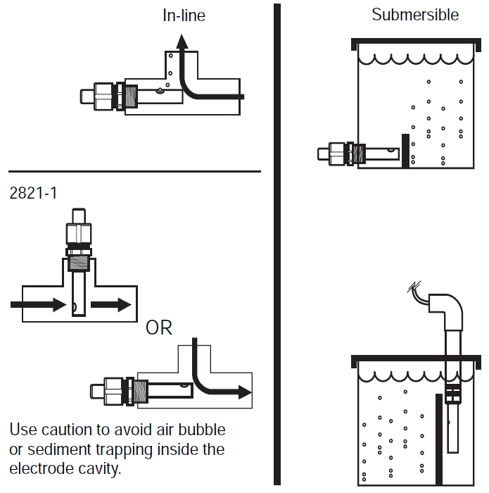

Figure .: Sensor Alignment[39]

### 3.1.4 Instrumentation and Methodology

The original series of sensors were used to ensure the same operating conditions as in the previous study. The experiment required an additional series of conductivity sensors in the original instrumentation setup. The Data Acquisition System (DAS) was flexible enough to accommodate the additional sensors. The conductivity sensors were strategically placed through the process to enhance the information collected while reducing costs by limiting the number of sensors. The Process and Instrumentation Diagram (P&ID) is outlined in Figure 3.4.

The Data Acquisition System (DAS) was connected to a local computer that ran Lab-View to monitor the sensor data. Lab-view would record the sensor data for all the sensors and output excel spreadsheets that were used for analysis.

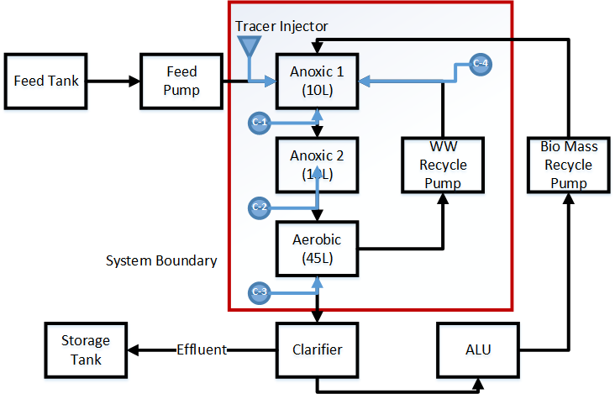

Figure .: Experiment System Boundaries

### 3.1.5 Tracer Injector

On the topic of injector systems, there are limited commercial products. One such product is the injector port used in medicine for different intravenous therapy (Figure 3.6). Researching such an injection port as well as obtaining one is difficult as it is highly regulated. The decision was made to make a custom solution for the problem.

There were two different tracer injector trials. The first trial utilized a t-connection, a rubber stopper, a syringe and a needle (Figure 3.7). The injector port design joined the t-connector and the rubber stopper. The tracer itself would be injected in a 10 mL syringe with a needle into the injection port. The T-connection was spliced into the feed line from the feeding tank to the first anoxic stage. The connector was placed close to the reactor in order to reduce any amount of lag introduced by the injection process.

The T-connector was a three-sided barbed connector with a 3/4 inch size that was purchased at a local Home Depot. The rubber stopper and the needle were generously supplied from the Chemistry department at Ryerson University. The syringe was provided from the Water treatment Technology lab at Ryerson University.

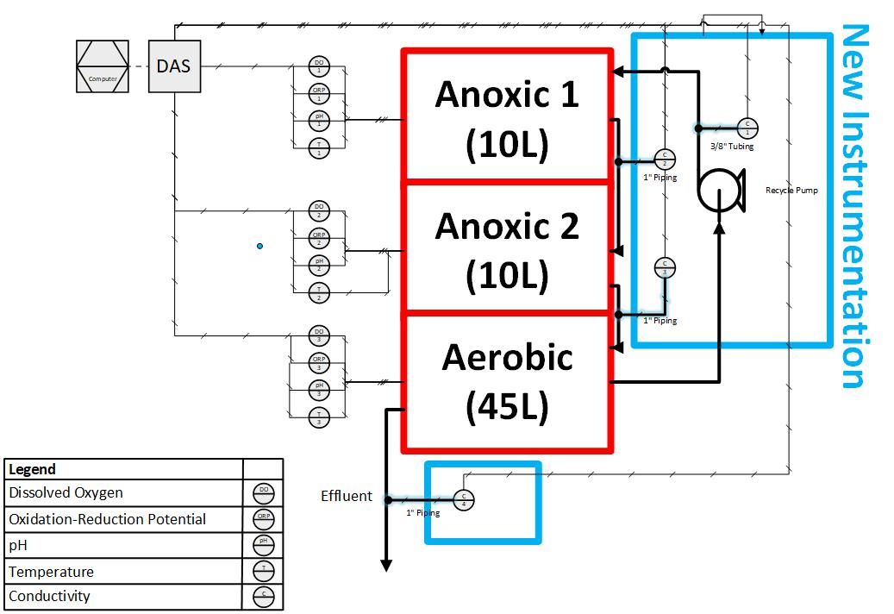

|  |
| --- |
|  |

Figure .: STAR reactor: Process and Instrumentation Diagram

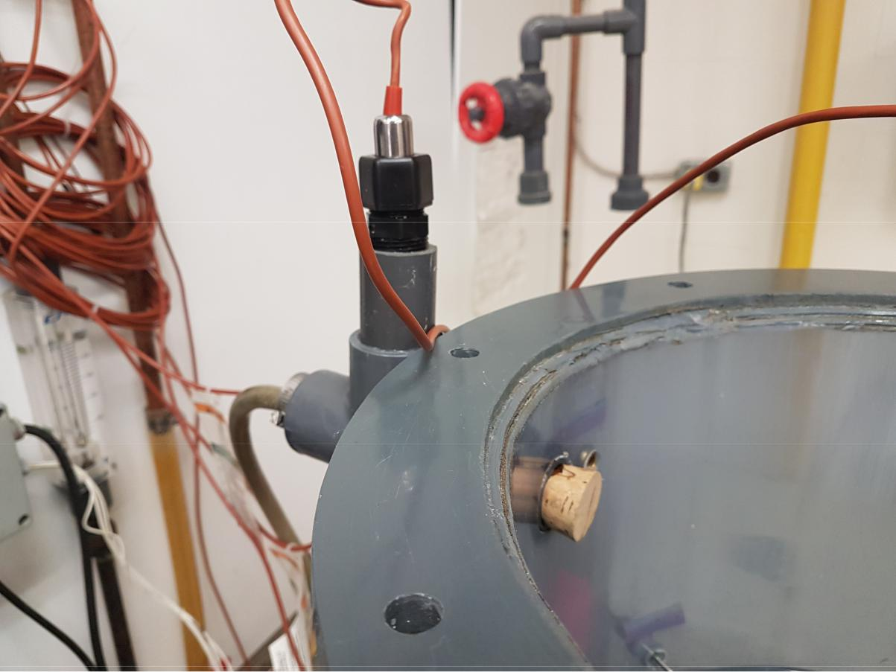

Figure .: Sensor #1 with a piece of Cork

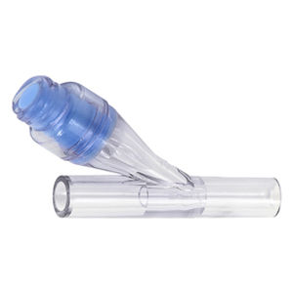

Figure .: Intravenous Therapy Injector Port[39]

|  |  |
| --- | --- |
| Stream | Flow rate (L/hr) |
|  |  |
| Feed | 10 |
| Internal Recycle | 20 |
| Recycle Sludge | 15 |
|  |  |

Table : Vertical Reactor Operating Conditions[1]

There was a 3/4 inch hole bored partially into the stopper that allowed the stopper to fit onto the t-connector. The theory behind the stopper was that the thick rubber would act as a self-healing surface that would withstand multiple injections without any leakage. This had been proven mostly successful; however, it was found that the injector did not provide enough tracer solution to provide any measurable data at the end of the reactor. This had led to the development of the second injector design.

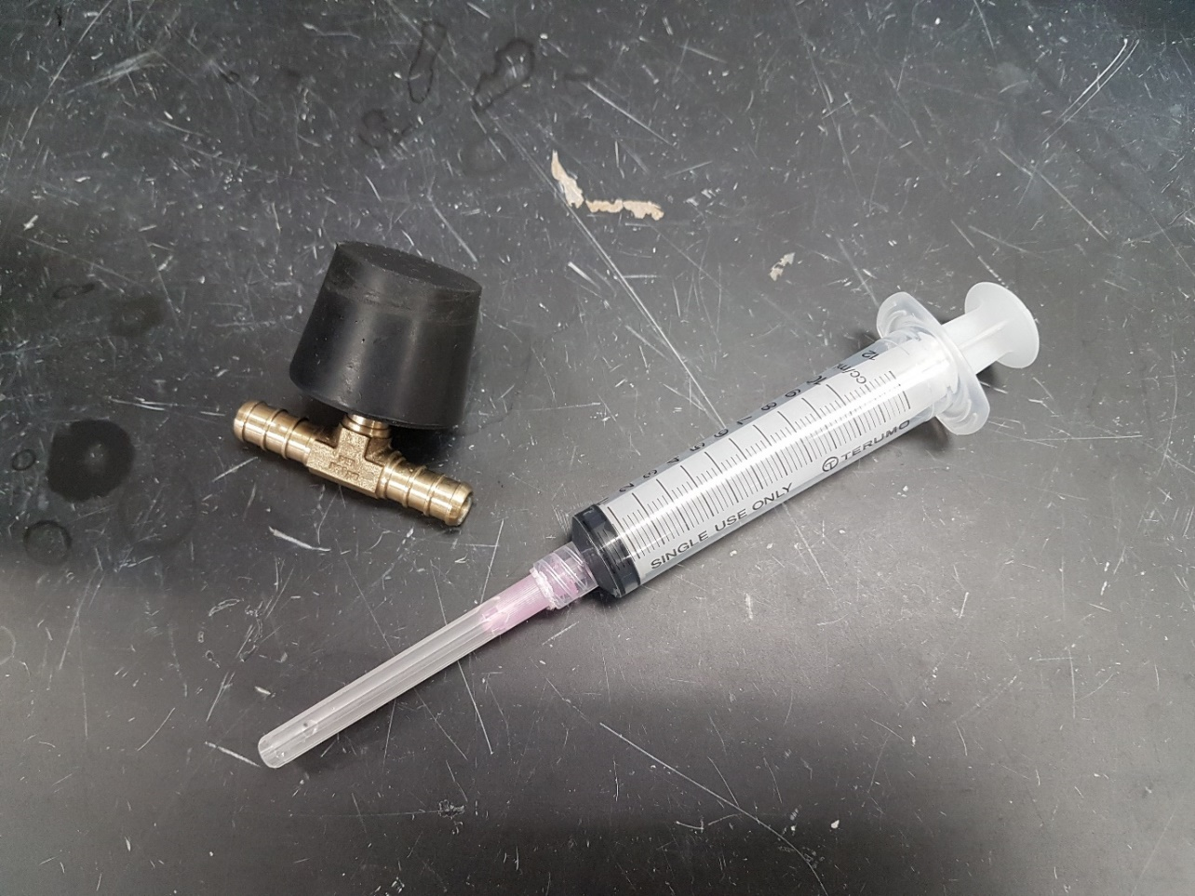The second injector design was much simpler; getting rid of the injector port all together (Figure 3.8). A larger 50 mL syringe was connected directly into the t-connection with a small length of tubing. The length of tubing was minimized in order to reduce any lag time and any dead space that would reduce that amount of tracer injected. Initially a rubber band was tied around the syringe to prevent back- flow into the injector but the pressure in the line was found to be insufficient to cause this effect.

Figure .: Tracer Injector trial 1

Different volumes of tracer were tested and it was found that 50 mL was sufficient. The operating conditions were maintained the same as literature values to ensure consistency (Table 5).

## 3.2 Data Analysis

### 3.2.1 Conductivity versus Concentration

The assumption that the conductivity of a tracer solution was linearly related to concentration of such solution was made. This assumption simplifies the creation of the RTD diagrams, as the conductivity measurements would require an additional conversion step to concentration.

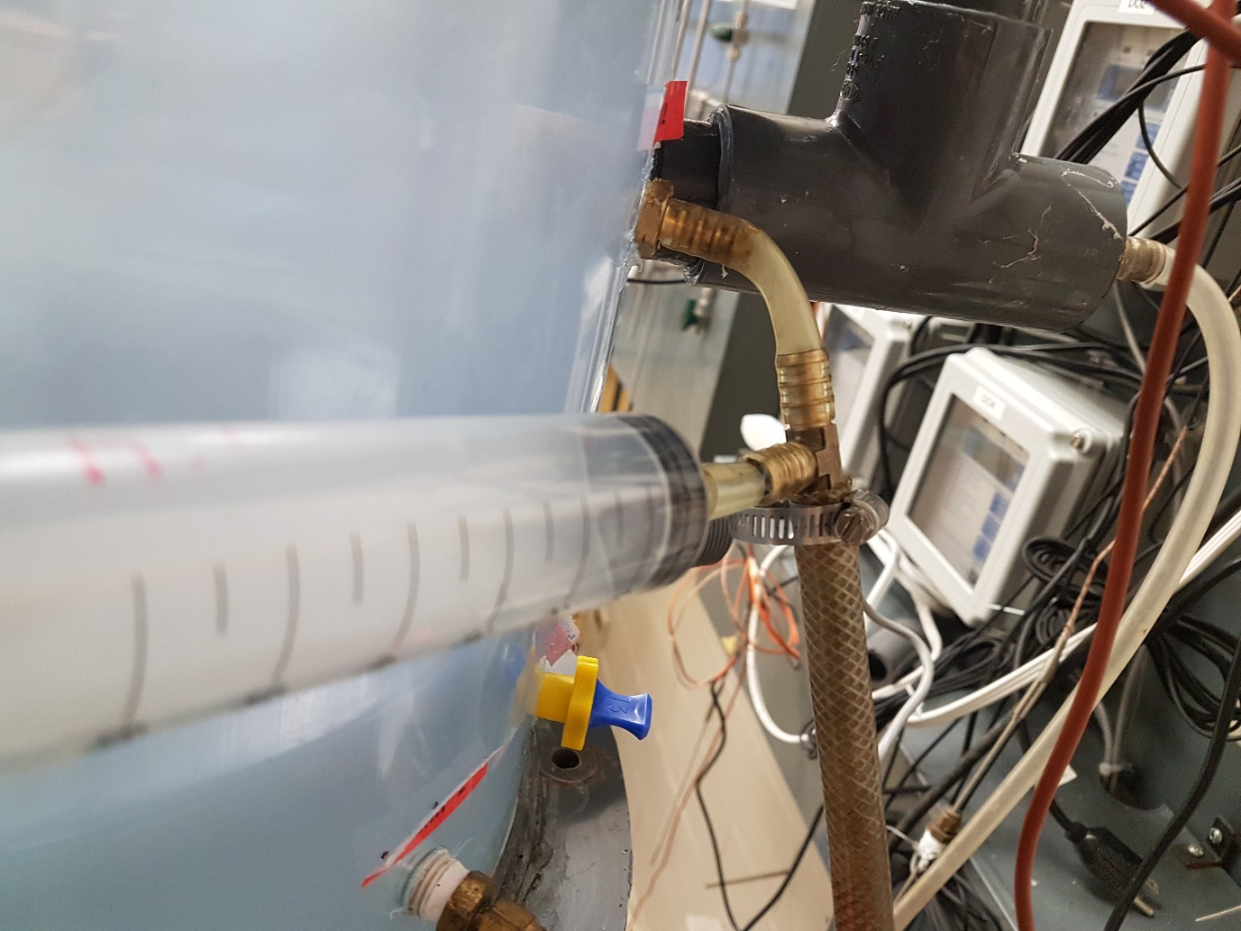Some of the conductivity sensors had shown strong evidence of wear with the formation of rust as evident in Figure 3.10 and Figure 3.9. Performing this assumption also had the additional benefit of eliminating the requirement of continuously re-calibrating the sensors. The sensor that exhibited wear still produced a reading but it would be inconsistent with other sensors. When transforming the readings into the dimensionless E (t) charts, any deviation between sensors would be removed. Only the sensors consistency with itself could provide a problem.

Figure .: Tracer Injector trial 2

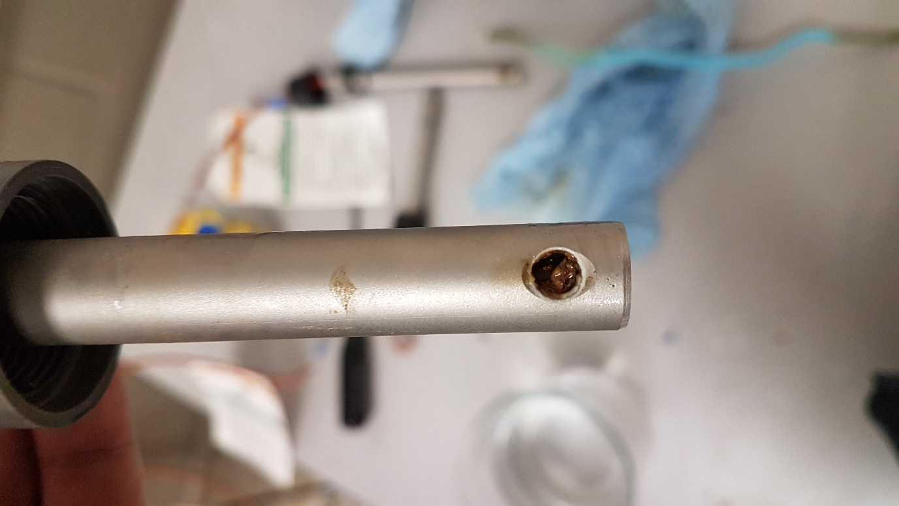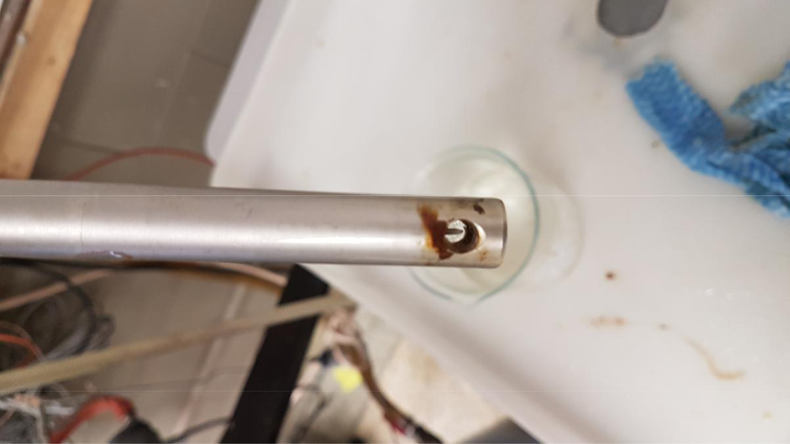

Figure .: The effect of rust

Figure .: Formation of rust

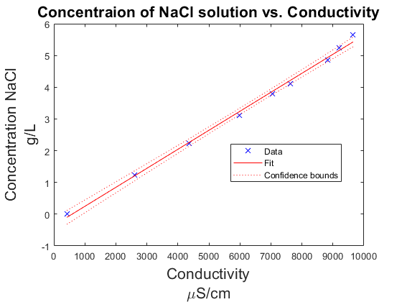In order to find the relationship between conductivity and concentration, a beaker of tap water was place on a hot plate with a magnetic stirrer. There was no requirement to use distilled or de-ionized water as the main feed in the reactor was tap water. The average conductivity would never be in the range of de-ionized water. With the use of a laboratory scale, small amounts of laboratory grade sodium chloride was added to the beaker. It is important to note that the behavior of laboratory sodium chloride is different than regular table salt. Table salt includes an anti-caking agent that prevents clumping and enhances ease of pouring.[67] Without the anti-caking agent, laboratory sodium chloride is much more difficult in measuring equal weights. The actual sensors used to develop the RTD diagrams were used to ensure consistency. A laboratory conductivity meter would have provided more accurate results of the relationship but the main interest is the effect on the specific sensors that are used.

Figure .: Concentration vs. Conductivity

Into total, eight different samples of sodium chloride that were added to the solution for nine different conductivity measurements. The experiment continued to a conductivity reading of 10,000 μS/cm as that is the maximum reading for the sensor and very close to the upper limit for the solubility of sodium chloride in water. The results of the experimentation can be found in Figure 3.11. It is evident of a strong linear relationship as the R2 value for the linear interpolation is 0.996. This justifies the assumption that they are directly related.

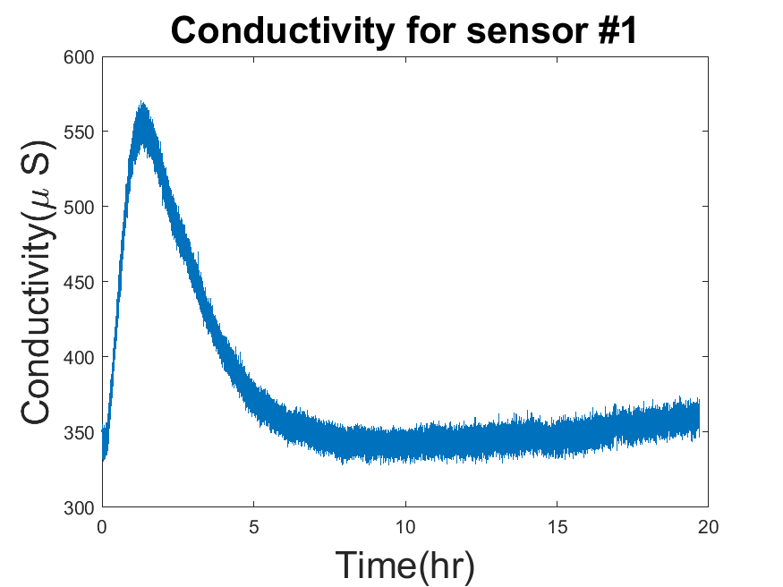

Figure .: Sample Conductivity Graph

### 3.2.2 Transformation to Population Density Function

Performing the tracer experiment produces results in a spreadsheet of the different conductivity measurements taken at the sample time of every three seconds. These tables were than expressed in a graphical format as observed in Figure 3.12.

A few issues need to be addressed to transform the sample results into the Population Density Function. Since the conductivity of tap water is inconsistent and not equal to zero, the initial and final values need to be accounted for in order to transform the conductivity graphs into RTD graphs. This task was initial completed by simply subtracting the lowest value from every value. This did not provide satisfactory results as the initial and final conductivity values differed. The fouling of the sensors due to rust deposits likely causes this. A linear regression model was implemented to solve this problem from the first ten and the last ten data points. This was achieved in Matlab utilizing the function “fitlm".

There was a large amount of noise from the collected samples so a regression model was used to clean up the data. It was later decided that the Matlab function "filter" using a moving average was a better solution. The amount of points to be affected by the filter was chosen experimentally. The lowest value that significantly cleaned up the data, to the point where is looked like a smooth curve was selected.

The next step was to change the values from a function of the concentration to a probability. This is achieved with the following equation:

[1] (3.1)

This formula based on the concentration of the tracer (C(t)) (M/L) but it is also true for any function of concentration such as the previously proven conductivity. There are a few numerical methods to find the integral from a set of data points but the trapezoidal method was selected for its ease of use and because it is already built into Matlab. The function can be describe by the following equation:

(3.2)

Experiments were performed with both the Simpson’s rule and Simpson’s 3/8 rule. There was minor differences in computational time and accuracy between methods especially with large data sets.

One advantage of using a concentration vs time graph is that the value of the integral across time is equal to the mass of tracer injected into the reactor. This provides an additional check to ensure that no tracer is absorbed by the system or lost. The value obtained from an arbitrary measurement, such as conductivity, provides no such benefit.[3]

The Population Density Function graph can now be used to evaluate different flow models but this evaluation is even easier if the E (t) is transformed in dimensionless time (θ). This requires the values of time (t) being divided by the Mean Residence Time (MRT) which can be calculated by this equation.

(3.3)

The transformation to dimensionless time requires the division of time by the MRT, , and the multiplication of the probability by the MRT, With this new plot, E(θ) vs. θ, models can be compared at the time constant (τ) =1. This will significantly simplify the process.

In statistics, a moment generating function is used to determine the properties of a distribution function.[68] These functions are used to compare different distributions. The first moment represents the MRT. The second moment is the variance of a distribution which is defined by the following equation:

(3.4)

The magnitude of the variance is an indication of the “spread" of the distribution.

The third moment is a quality referred to as the skewness. It is a measure of the extent that a distribution is skewed in one direction or the other in reference to the mean. It is observed as a tail. It is defined as:

(3.5)

The first and the second moments are the most commonly used parameters to characterize a RTD function.

## 3.3 Model Testing

Different models were examined against the collected Dimensionless Population Density Function (E(θ)) for the different sections of the STAR reactor. These proposed models were evaluated with a custom Mat-lab function based on Root Mean Square Error (RMSE), which is described in equation (3.6).

(3.6)

## 3.4 Recycle Experiment

The tracer experiment was run without the systems internal recycle. The recycle sludge streamed was also turned off, as it would increase the overall volumetric flow-rate. This allowed the determination of the observed MRT through a single run. The effect of the addition of the recycle on the MRT can be observed. Optimization of the MRT by controlling the internal recycle rate can then be considered.

## 3.5 Characteristic Parameters

The data provided by the internal recycle testing allows for additional testing for dead space and by-passing (as described in section 2.3.3). The theoretical mean residence time can be calculated by the following equation:

Where τ is the theoretical mean residence time (hours), V is the total reactor volume (Liters) and v is the volumetric flow rate (Liters/hour). The total volume is the sum of the volumes of each section: V = Vanoxic1 + Vanoxic2 + Vaerobic = 10L + 10L + 45L = 65L. The volumetric flow rate was maintained at 10L=hr resulting in a τ = 6:5hrs. The observed MRT can be found with the following equation:

As a summary of section 2.3.3, the following relationship is true:

The quantities of Hold-back (H) and Segregation (S) were also found as described in section 2.3.4. The values were obtained after finding the Distribution Function (F (t)) from the Population Density Function (E (t)). They are related from the following equation:

All of these values were obtained with the use of Matlab scripts.

# : Results

## 4.1 Tracer Experiment

The following multiple plot (Figure 4.1) represents the raw data collected from the tracer experiment on December, 19, 2019. A sample of 50mL of saturated tracer solution was injected a few seconds after the initial sampling. The sampling rate was set to three seconds for the conductivity sensors. There is a plot for each conductivity sensor, which represent the effluent of each stage of the reactor and the internal recycle. The graphs show the trend of the tracer throughout the stages. There is some noise in the raw data but the general trend can be observed.

The consistency of the results was testing on repeated trials. The overall RTD for the different trial are examined on Figure 4.2. There are some deviations between the trials as they exhibited different conditions (ex. tracer volumes) but their overall behaviour is consistent. Table 6 illustrates the error between each of the trials. This measurement of error will be used as a benchmark for the model testing. The first and second moments (Mean Residence Time and Variance) of the RTD for three different trials are summarized in Table 7.

Figure 4.3represents the dimensionless RTD function for the fourth sensor representing the effluent from the entire reactor. The plot exhibits a large thin peak followed by two wide but shorter peaks. The distance between each peaks is around 0.75 times the mean residence time. Figure (4.4) @@shows the dimensionless RTD for the raw data represented in Figure 4.1.

|  |  |
| --- | --- |
| Compared Trials | RSME |
|  |  |
| Trial 1 and 2 | 0.206 |
| Trial 1 and 3 | 0.284 |
| Trial 2 and 3 | 0.364 |
|  |  |
| Average | 0.285 |
|  |  |

Table : Error between different trials, E(θ)

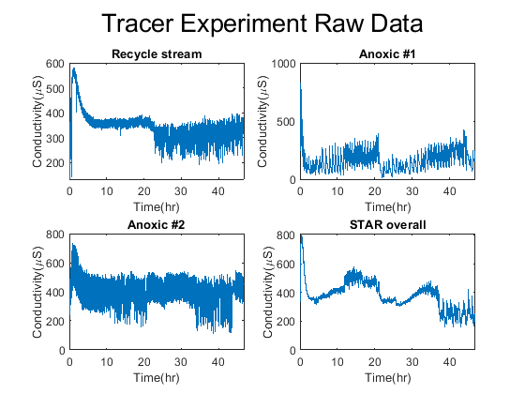

Figure .: Raw Data of tracer experiment

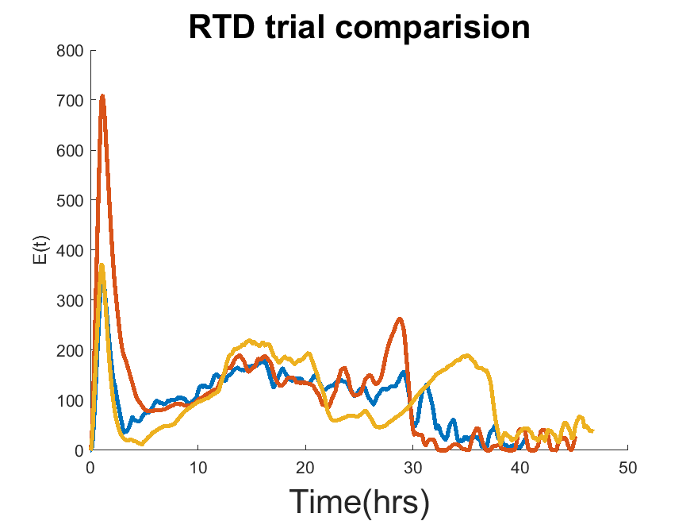

Figure .: different RTD trials for overall reactor

|  |  |  |
| --- | --- | --- |
|  | Mean Residence Time(hrs) | Variance |
|  |  |  |
| Trial 1 | 16.9 | 94.7 |
| Trial 2 | 14.7 | 113.5 |
| Trial 3 | 21.2 | 141.6 |
|  |  |  |
| Average | 17.6 | 116.6 |
|  |  |  |

Table : RTD characteristics of different trials

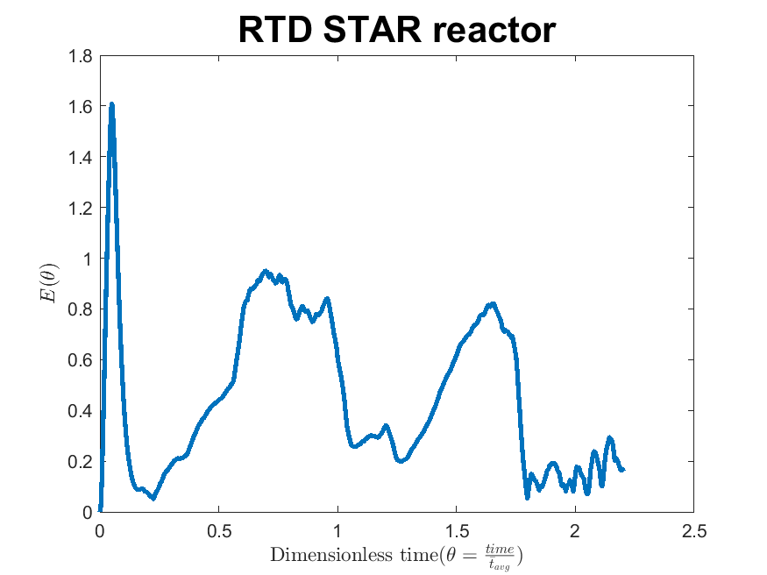

Figure .: STAR reactor Residence Time Distribution Function

|  |  |  |  |  |  |  |  |
| --- | --- | --- | --- | --- | --- | --- | --- |
|  | CSTRR | PFR | Low D | DispOpen | CSTRS | Nth CSTR | E-CSTRS |
| Trial 1 | 0.27 | 92.47 | 0.18 | 0.25 | 0.25 | 0.25 | 0.20 |
| Trial 2 | 0.27 | 75.05 | 0.30 | 0.37 | 0.27 | 0.27 | 0.26 |
| Trial 3 | 0.37 | 107.43 | 0.29 | 0.32 | 0.32 | 0.32 | 0.30 |
| Average (fit) | 0.30 | 91.65 | 0.26 | 0.31 | 0.28 | 0.28 | 0.25 |

Table : Model Test Summary

## 4.2 Model Testing

Figure 4.5 demonstrates how the Ideal models fit the RTD for this trial while Figure 4.6 and Figure 4.7 test different real reactor models. The behaviour of RTD is closer to that of the Ideal CSTR than it is of the Ideal PFR. The difference in error between the two ideal conditions is on a factor of 3.

There are three reactor models in Figure 4.6 and two models in Figure 4.7. The real reactors are all better fits for the RTD than the previous ideal reactor models. Table 8 shows the average error measured for each of the models against three different experiment trials while Table 9 summarizes their parameters of best fit. The enhanced CSTR in series model shows the best fit for the data, but it is on the same scale as the ideal CSTR.

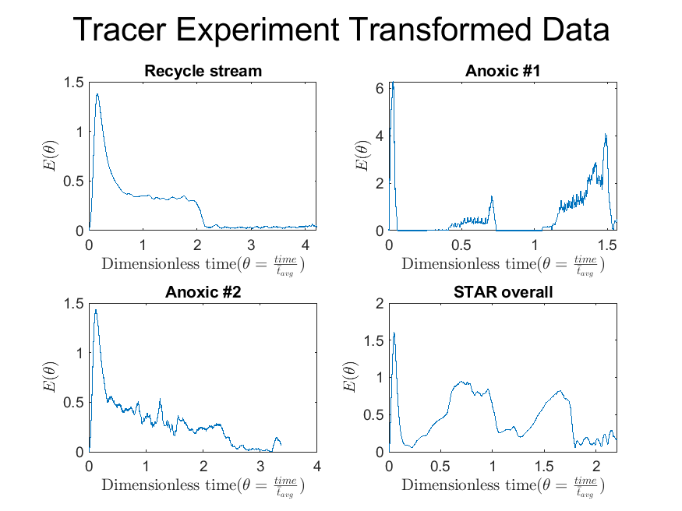

Figure .: Transformed Dimensionless Residence Time Distribution

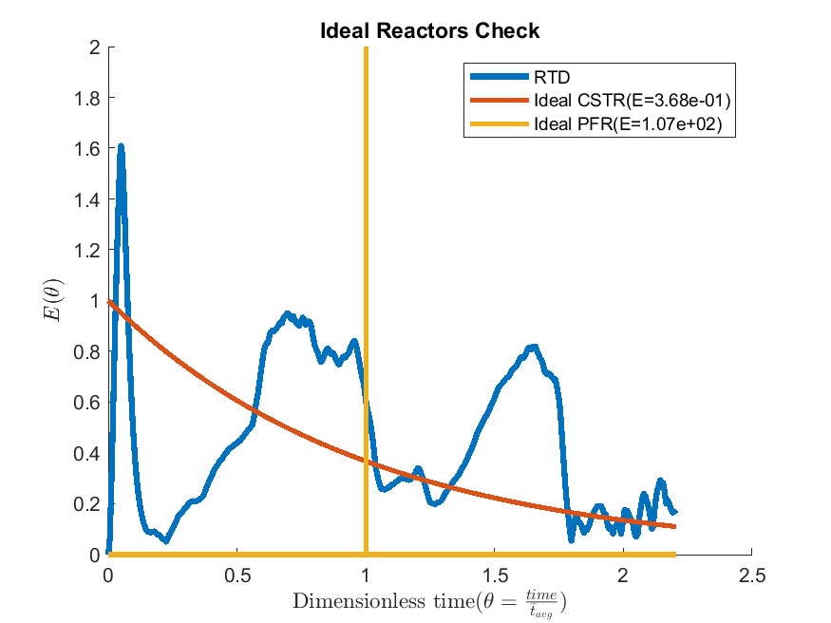

Figure .: Ideal Models Test

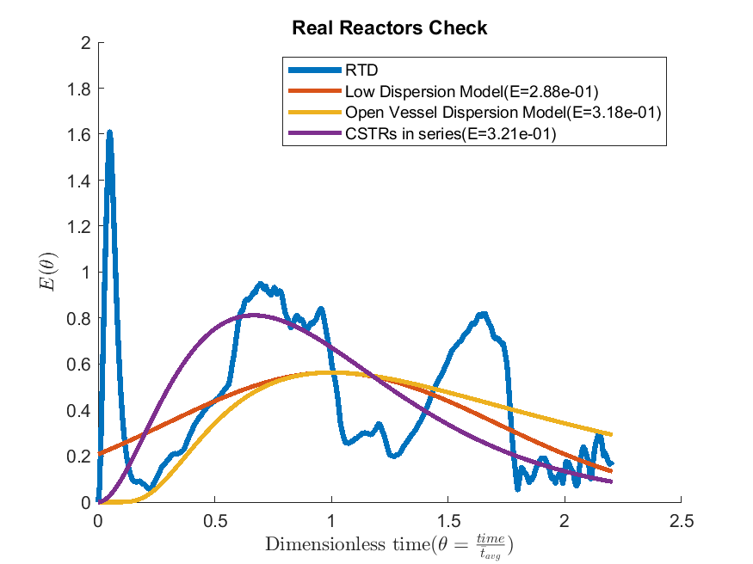

Figure .: Real Reactor Models Test

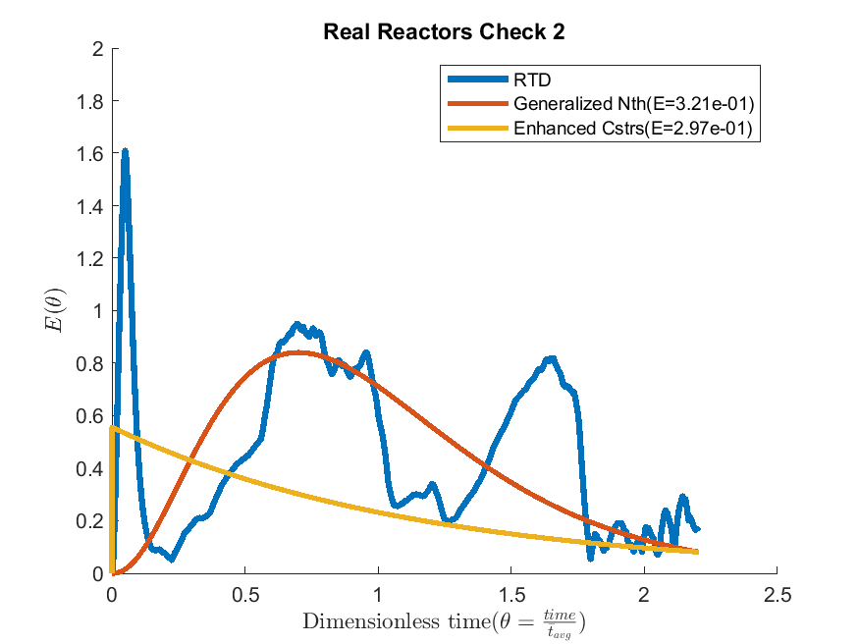

Figure .: Real Reactor Models Test cont.

|  |  |  |  |  |  |  |  |
| --- | --- | --- | --- | --- | --- | --- | --- |
|  | Low D | Open D | #CSTRS | #nthCSTRS | #ECSTRS | n min | M min |
| Trial 1 | 0.25 | 0.25 | 2 | 1.52 | 3 | 0.64 | 1 |
| Trial 2 | 0.42 | 0.67 | 1 | 1 | 1 | 0.55 | 0.36 |
| Trial 3 | 0.25 | 0.25 | 3 | 3.34 | 1 | 0.64 | 0.73 |
| Average | 0.31 | 0.39 | 2 | 1.95 | 2 | 0.61 | 0.7 |

Table : Model Optimal Parameters

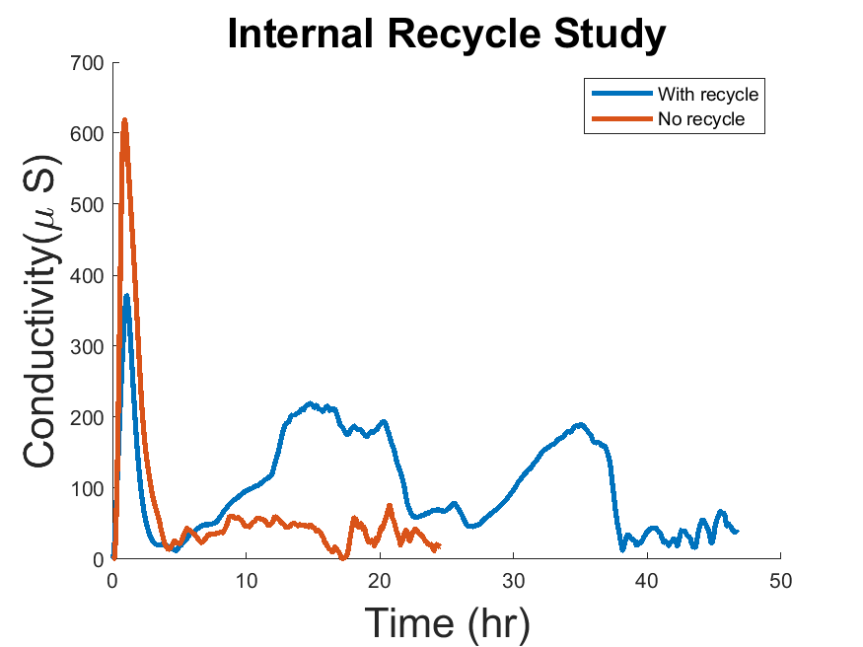

Figure .: Internal Recycle Study

## 4.3 Internal Recycle Experiment

Figure (4.8) shows the results of the RTD with and without the internal recycle turned on. The initial peak for both trials are located at the same time but the probability is much lower when there is a recycle. The RTD with respect to time was compared rather than the dimensionless time because the two plot have two different mean residence times. The second and third peaks are not present in the trial without the recycle.

## 4.4 Characteristic Parameters

### 4.4.1 Dead Space and By-passing

The mean residence time for the system without a recycle was found to be 7.02 hrs. This value is compared to the theoretical mean residence time for the reactor of 6.5hrs. As the observed mean residence time is larger than the theoretical, this signifies by-passing in the system. The volumetric flow rate for by-passing was found to be 0.75 L/hr which represents 7.5% of the flow rate in the feed stream.

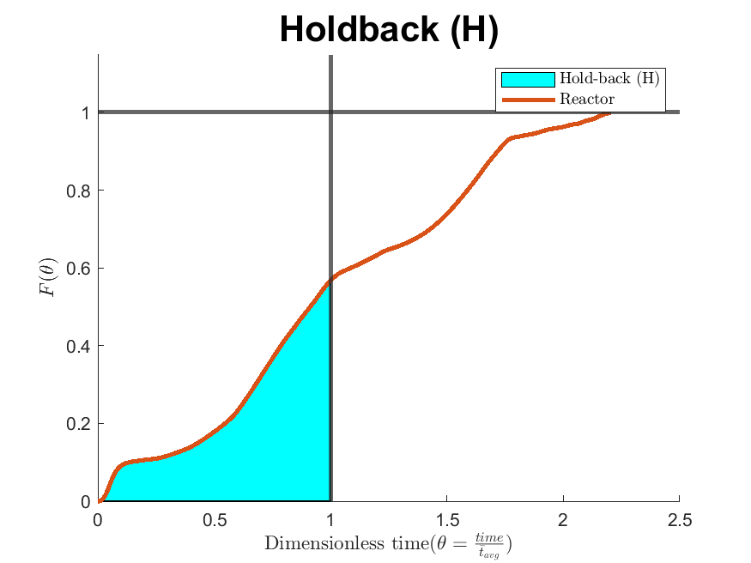

Figure .: Hold-back for the vertical bioreactor

### 4.4.2 Hold-back and Segregation

The plot for the Distribution Function (F (t)) was found with Matlab using the “trapz" function across the Population Density Function (E (t)). The Hold-Back value of H was than obtained from the area under the curve from θ = 0 to θ = 1. This area was found again with the “trapz" function in Matlab (Figure 4.9). The value H was found to be 0.2365.

The value for segregation (S) was found from plotting the F (t) with the F (t) for the ideal CSTR. The intersecting points were found with a Matlab script. Since the plots do not meet at set points, a certain tolerance (< 0.00001) was used to find their intersection. The intersection points than had to be hard coded into the Matlab program. From the plot (Figure 4.10), it may appear that the system exhibits a dead space with the CSTR proceeding the system. This is incorrect as there is a small region where the system proceeds the CSTR which is difficult to observe due to the scaling of the figure. The zoomed-in Figure 4.11 more clearly shows that the CSTR does in fact proceed the reactor. This is evidence that there is no dead space in the system. The value of segregation (S) was found to be -0.16.

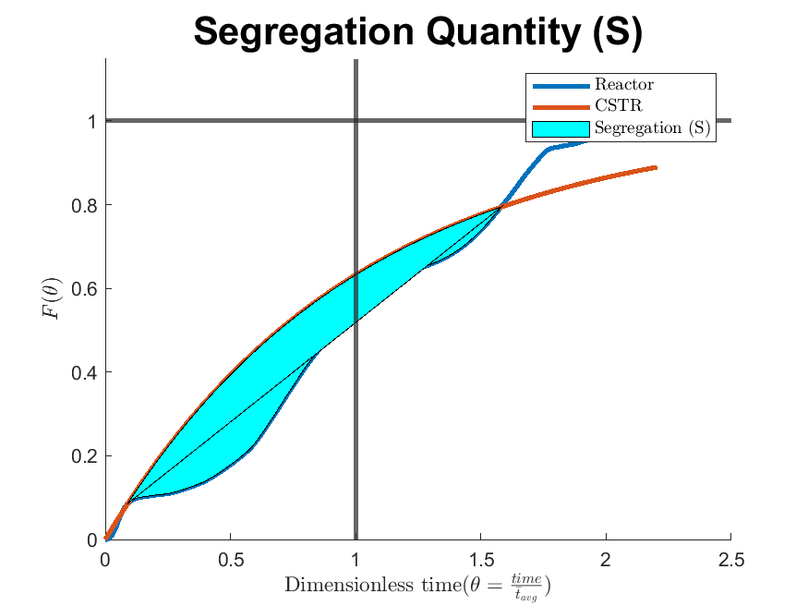

Figure .: Segregation (S) for the vertical bioreactor

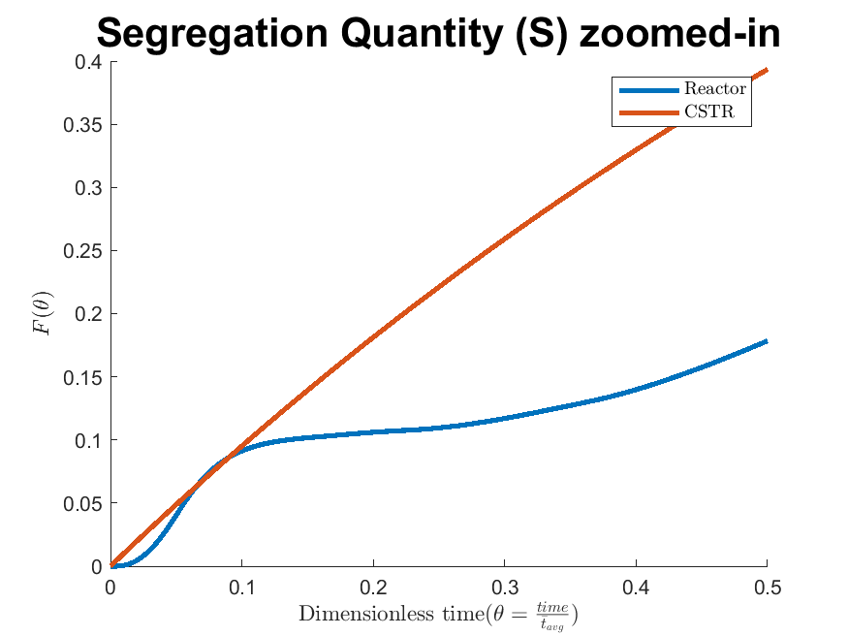

Figure .: Zoomed-in Segregation (S)

# : Discussion

The results of the tracer experiment show that the mixing profile of the vertical bioreactor can be obtained. A plot of the Residence Time Distribution (RTD) was obtained and repetition had had shown to be consistent (Figure 4.2). Through analysis of the constructed RTD, different mixing models were evaluated. Table 8 shows that all of the CSTR in series model variants (including generalized Nth and the enhanced), the open and low dispersion models as well as the ideal CSTR accurately fit the mixing profile. It is of note that the dispersion coefficients (0.31 for low and 0.39 for open) are much greater than 0.01 and thus represent a large deviation from Plug Flow[3].

This evidence suggest a high level of mixing in a vertical bioreactor. The ideal CSTR was a very good fit while the ideal PFR was very poor. This is important for two reasons:

* It supports the claim of a high level of mixing due to the reactor geometry[2]
* High levels of mixing are desirable for wastewater treatment bioreactors

Secondary findings - based on the internal recycle testing - that the reactor exhibits a by-passing of 7.5% of the feed stream. The values for the Hold-back (0.2365) and for Segregation (-0.16) were both found. In both cases, their values were close to the ideal CSTR (H 0.3679 and S = 0 respectively).

All evidence collected suggest a high level of mixing within the vertical bioreactor. It supports the claimed of a high level of mixing due to the tubular geometry. Conventional bioreactors in wastewater engineering exhibit poor mixing profiles and poor conversions (due their reaction kinetics). The field of Biological Nutrient Removal (BNR) research is ever expanding and more research into vertical bioreactors is promising.

Some limitations of this research include the assumption that the reactor with clean water will act the same as wastewater. This is a generally accepted assumption, as the density of activated sludge does not vary much for water. There is also a time constraint to consider as the reactor originally took 230 days for the biomass to get to a steady state[2]. In order to insure that each sensor was adequately submerged, fluid levels were “held-back". These actions will in fact affect the flow dynamics of the system to some small degree. These measures were however necessary to obtain consistent readings.

The next step for this research would be the application of the wastewater reaction kinetics (such as the ASM2D mentioned in the literature review) across the developed model. These models still require kinetic parameters, which can be found in literature, but due to the complicated nature of a mixed population of microbes would be best found experimentally. This experiment can be performed by seeding the reactor with microbes and developing the population. Samples from each section would be taken and their reaction kinetics found in a batch reactor.

There could be some value in modeling the vertical bioreactor with a Computational Fluid Dynamics (CFD). CFDs can identify the physical locations of dead space and by-pass within the reactor. There was found to be 7.5% by-passing in the reactor which could be better identified with a CFD. A potential source of by-passing was observed in the anoxic zone 2 Figure 5.1 which was not addressed due to time restraints. Addressing this concern than determining the new amount of by-passing would be an easier solution.

The vertical bioreactor has been tested experimentally and shown to be well represented by a CSTR. There is some potential value of using more complicated models to represent the mixing profile such as the Axial Dispersion model or the Generalized N-CSTR in series model. They both require only one parameter but the Axial Dispersion model may give some the impression that the system is similar to the PFR. It is important to remember that the Dispersion coefficient is very high which represents a large deviation for the ideal PFR. The system also exhibits by-passing of 7.5%.

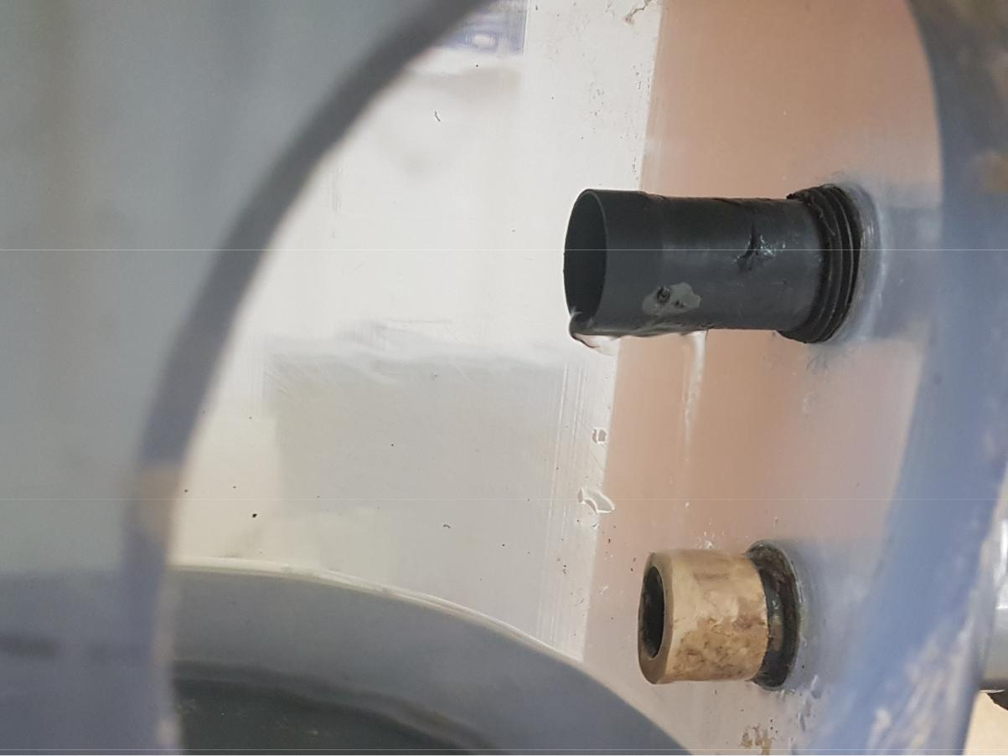

Figure .: Potential source of by-passing

# : Conclusions

The mixing profile for a vertical bioreactor was found by performing a tracer experiment. A tracer solution of 50mL saturated NaCl was injected at the entrance of the reactor and the conductivity was measured at the exit of each stage. The collected data was then converted into the dimensionless Residence Time Distribution (RTD). The behaviour of the flow was interpreted from these results with the effect of the internal recycle evident. There was no evidence of dead space but 7.5% by-passing was found.

The mixing profile was than compared to both ideal and real reactor models. It was found that the generalized Nth CSTR in series model and the Ideal CSTR fit the mixing profile well. The parameters for Hold-back (H) and Segregation (S) were found to be 0.2365 and -0.16 respectively. In both cases, this suggest a high level of mixing similar to the ideal CSTR behaviour.

# Appendix

Appendix 1: Gamma function

The Gamma function was used to expand the use of a factorial from all natural number () to all real numbers () in the Nth generalized CSTR in series model by Martin. The Gamma function has been defined by Eular as the following:

Where the following conditions are also satisfied:

# Bibliography

[1] M. Reza and M. Alvarez Cuenca, “Nitrification and denitrifying phosphorus removal in an upright continuous flow reactor,” *Water Science and Technology*, vol. 73, no. 9, pp. 2093–2100, May 2016, doi: 10.2166/wst.2016.057.

[2] M. Reza, “Simultaneous Removal of Ammonia and Phosphorus from Wastewater in a Continuous Flow Vertical Bioreactor,” p. 203.

[3] O. Levenspiel, *Chemical reaction engineering*, 3rd ed. New York: Wiley, 1999.

[4] A. Barwal and R. Chaudhary, “To study the performance of biocarriers in moving bed biofilm reactor (MBBR) technology and kinetics of biofilm for retrofitting the existing aerobic treatment systems: a review,” *Rev Environ Sci Biotechnol*, vol. 13, no. 3, pp. 285–299, Sep. 2014, doi: 10.1007/s11157-014-9333-7.

[5] B. Young, B. Banihashemi, D. Forrest, K. Kennedy, A. Stintzi, and R. Delatolla, “Meso and micro-scale response of post carbon removal nitrifying MBBR biofilm across carrier type and loading,” *Water Research*, vol. 91, pp. 235–243, Mar. 2016, doi: 10.1016/j.watres.2016.01.006.

[6] L. Deng *et al.*, “New functional biocarriers for enhancing the performance of a hybrid moving bed biofilm reactor–membrane bioreactor system,” *Bioresource Technology*, vol. 208, pp. 87–93, May 2016, doi: 10.1016/j.biortech.2016.02.057.

[7] E. Arnold, B. Böhm, and P. A. Wilderer, “Application of activated sludge and biofilm sequencing batch reactor technology to treat reject water from sludge dewatering systems: a comparison,” *Water Science and Technology; London*, vol. 41, no. 1, pp. 115–122, Jan. 2000.

[8] K. Li, F. Fang, J. Guo, Y. Chen, J. Yang, and H. Wei, “Performance of one-stage autotrophic nitrogen removal in a biofilm reactor with low C/N ratio,” *Environmental Technology*, vol. 36, no. 14, pp. 1819–1827, Jul. 2015, doi: 10.1080/09593330.2015.1013569.

[9] J. Yin, P. Zhang, F. Li, G. Li, and B. Hai, “Simultaneous biological nitrogen and phosphorus removal with a sequencing batch reactor–biofilm system,” *International Biodeterioration & Biodegradation*, vol. 103, pp. 221–226, Sep. 2015, doi: 10.1016/j.ibiod.2015.02.019.

[10] H. Xiao, P. Yang, H. Peng, Y. Zhang, S. Deng, and X. Zhang, “Nitrogen removal from livestock and poultry breeding wastewaters using a novel sequencing batch biofilm reactor,” *Water Science and Technology*, vol. 62, no. 11, pp. 2599–2606, Dec. 2010, doi: 10.2166/wst.2010.534.

[11] M. Chaali, M. Naghdi, S. K. Brar, and A. Avalos‐Ramirez, “A review on the advances in nitrifying biofilm reactors and their removal rates in wastewater treatment,” *Journal of Chemical Technology & Biotechnology*, vol. 93, no. 11, pp. 3113–3124, 2018, doi: 10.1002/jctb.5692.

[12] B. Günder and K. Krauth, “Replacement of Secondary Clarification by Membrane Separation-Results with Tubular, Plate and Hollow Fibre Modules,” *Water Science and Technology; London*, vol. 40, no. 4–5, pp. 311–320, Aug. 1999.

[13] Ch. Brepols *et al.*, “Upgrading and retrofitting of municipal wastewater treatment plants by means of membrane bioreactor (MBR) technology,” *Desalination*, vol. 231, no. 1, pp. 20–26, Oct. 2008, doi: 10.1016/j.desal.2007.11.035.

[14] M. Kraume and A. Drews, “Membrane Bioreactors in Waste Water Treatment – Status and Trends,” *Chemical Engineering & Technology*, vol. 33, no. 8, pp. 1251–1259, 2010, doi: 10.1002/ceat.201000104.

[15] H. Monclús, J. Sipma, G. Ferrero, I. Rodriguez-Roda, and J. Comas, “Biological nutrient removal in an MBR treating municipal wastewater with special focus on biological phosphorus removal,” *Bioresource Technology*, vol. 101, no. 11, pp. 3984–3991, Jun. 2010, doi: 10.1016/j.biortech.2010.01.038.

[16] F. Sun, X. Wang, and X. Li, “An innovative membrane bioreactor (MBR) system for simultaneous nitrogen and phosphorus removal,” *Process Biochemistry*, vol. 48, no. 11, pp. 1749–1756, Nov. 2013, doi: 10.1016/j.procbio.2013.08.009.

[17] M. A. H. Johir *et al.*, “Removal of phosphorus by a high rate membrane adsorption hybrid system,” *Bioresource Technology*, vol. 201, pp. 365–369, Feb. 2016, doi: 10.1016/j.biortech.2015.11.045.

[18] U. Bracklow, L. Manigas, A. Drews, M. Vocks, M. Barjenbruch, and M. Kraume, “Impact of different recirculation schemes on nitrogen removal and overall performance of a laboratory scale MBR,” *Water Science and Technology; London*, vol. 56, no. 6, pp. 115–124, Sep. 2007, doi: http://dx.doi.org.ezproxy.lib.ryerson.ca/10.2166/wst.2007.641.

[19] R. Wang, F. Xiao, Y. Wang, and Z. Lewandowski, “Determining the optimal transmembrane gas pressure for nitrification in membrane-aerated biofilm reactors based on oxygen profile analysis,” *Appl Microbiol Biotechnol*, vol. 100, no. 17, pp. 7699–7711, Sep. 2016, doi: 10.1007/s00253-016-7553-1.

[20] K. Hibiya, A. Terada, S. Tsuneda, and A. Hirata, “Simultaneous nitrification and denitrification by controlling vertical and horizontal microenvironment in a membrane-aerated biofilm reactor,” *Journal of Biotechnology*, vol. 100, no. 1, pp. 23–32, Jan. 2003, doi: 10.1016/S0168-1656(02)00227-4.

[21] M. Aybar, G. Pizarro, J. P. Boltz, L. Downing, and R. Nerenberg, “Energy-efficient wastewater treatment via the air-based, hybrid membrane biofilm reactor (hybrid MfBR),” *Water Science and Technology; London*, vol. 69, no. 8, pp. 1735–1741, Apr. 2014, doi: http://dx.doi.org.ezproxy.lib.ryerson.ca/10.2166/wst.2014.086.

[22] S. Judd and C. Judd, *The MBR Book: Principles and Applications of Membrane Bioreactors for Water and Wastewater Treatment*. Jordan Hill, UNITED KINGDOM: Elsevier Science & Technology, 2006.

[23] P. Le-Clech, V. Chen, and T. A. G. Fane, “Fouling in membrane bioreactors used in wastewater treatment,” *Journal of Membrane Science*, vol. 284, no. 1–2, pp. 17–53, Nov. 2006, doi: 10.1016/j.memsci.2006.08.019.

[24] A. Drews, “Membrane fouling in membrane bioreactors—Characterisation, contradictions, cause and cures,” *Journal of Membrane Science*, vol. 363, no. 1–2, pp. 1–28, Nov. 2010, doi: 10.1016/j.memsci.2010.06.046.

[25] F. Meng, S.-R. Chae, A. Drews, M. Kraume, H.-S. Shin, and F. Yang, “Recent advances in membrane bioreactors (MBRs): Membrane fouling and membrane material,” *Water Research*, vol. 43, no. 6, pp. 1489–1512, Apr. 2009, doi: 10.1016/j.watres.2008.12.044.

[26] M. Martínez, “Nitrogen and phosphorus removal from urban wastewater by the microalga Scenedesmus obliquus,” *Bioresource Technology*, vol. 73, no. 3, pp. 263–272, Jul. 2000, doi: 10.1016/S0960-8524(99)00121-2.

[27] J. Shi, B. Podola, and M. Melkonian, “Removal of nitrogen and phosphorus from wastewater using microalgae immobilized on twin layers: an experimental study,” *J Appl Phycol*, vol. 19, no. 5, pp. 417–423, Aug. 2007, doi: 10.1007/s10811-006-9148-1.

[28] J. A. Borchardt and H. S. Azad, “Biological Extraction of Nutrients,” p. 17, 2020.

[29] A. Ruiz-Martinez, N. Martin Garcia, I. Romero, A. Seco, and J. Ferrer, “Microalgae cultivation in wastewater: Nutrient removal from anaerobic membrane bioreactor effluent,” *Bioresource Technology*, vol. 126, pp. 247–253, Dec. 2012, doi: 10.1016/j.biortech.2012.09.022.

[30] J. T. Bunce, E. Ndam, I. D. Ofiteru, A. Moore, and D. W. Graham, “A Review of Phosphorus Removal Technologies and Their Applicability to Small-Scale Domestic Wastewater Treatment Systems,” *Front. Environ. Sci.*, vol. 6, p. 8, Feb. 2018, doi: 10.3389/fenvs.2018.00008.

[31] D. S. Parker and And Others, *Process Design Manual for Nitrogen Control*. 1975.

[32] W. E. Federation, *Biological Nutrient Removal (BNR) Operation in Wastewater Treatment Plants : WEF Manual of Practice No. 30: WEF Manual of Practice*. McGraw-Hill Education, 2005.

[33] W. C. Hiatt and C. P. L. Grady, “An Updated Process Model for Carbon Oxidation, Nitrification, and Denitrification,” *Water Environment Research*, vol. 80, no. 11, pp. 2145–2156, Nov. 2008, doi: 10.2175/106143008X304776.

[34] I. Iacopozzi, V. Innocenti, S. Marsililibelli, and E. Giusti, “A modified Activated Sludge Model No. 3 (ASM3) with two-step nitrification–denitrification,” *Environmental Modelling & Software*, vol. 22, no. 6, pp. 847–861, Jun. 2007, doi: 10.1016/j.envsoft.2006.05.009.

[35] G. Tchobanoglous, F. L. Burton, H. D. Stensel, and Metcalf & Eddy, Eds., *Wastewater engineering: treatment and reuse*, 4th ed. Dubuque, IA ; Toronto: McGraw-Hill, 2002.

[36] M. Henze, Ed., *Biological wastewater treatment: principles, modelling and design*. London: IWA Pub, 2008.

[37] G. W. Fuhs and M. Chen, “Microbiological basis of phosphate removal in the activated sludge process for the treatment of wastewater,” *Microb Ecol*, vol. 2, no. 2, pp. 119–138, Jun. 1975, doi: 10.1007/BF02010434.

[38] H. T. T. Nguyen, V. Q. Le, A. A. Hansen, J. L. Nielsen, and P. H. Nielsen, “High diversity and abundance of putative polyphosphate-accumulating Tetrasphaera-related bacteria in activated sludge systems: Tetrasphaera-related bacteria in activated sludge systems,” *FEMS Microbiology Ecology*, vol. 76, no. 2, pp. 256–267, May 2011, doi: 10.1111/j.1574-6941.2011.01049.x.

[39] R. Kristiansen *et al.*, “A metabolic model for members of the genus Tetrasphaera involved in enhanced biological phosphorus removal,” *ISME J*, vol. 7, no. 3, pp. 543–554, Mar. 2013, doi: 10.1038/ismej.2012.136.

[40] M. Henze *et al.*, “Activated Sludge Model No.2d, ASM2D,” *Water Science and Technology; London*, vol. 39, no. 1, pp. 165–182, Jan. 1999.

[41] P. V. Danckwerts, “Continuous flow systems: Distribution of residence times,” *Chemical Engineering Science*, vol. 2, no. 1, pp. 1–13, Feb. 1953, doi: 10.1016/0009-2509(53)80001-1.

[42] Th. N. Zwietering, “The degree of mixing in continuous flow systems,” *Chemical Engineering Science*, vol. 11, no. 1, pp. 1–15, Aug. 1959, doi: 10.1016/0009-2509(59)80068-3.

[43] T. Salmi, J.-P. Mikkola, and P. Warna, *Chemical reaction engineering and reactor technology*. Boca Raton: CRC Press, 2011.

[44] R. W. Missen, C. A. Mims, and B. A. Saville, *Introduction to chemical reaction engineering and kinetics*. New York: J. Wiley, 1999.

[45] S. Goswami, H. J. Pant, D. Poswal, J. S. Samantray, and S. R. Asolekar, “Investigation of flow dynamics of wastewater in a pilot-scale constructed wetland using radiotracer technique,” *Applied Radiation and Isotopes*, vol. 147, pp. 70–75, May 2019, doi: 10.1016/j.apradiso.2019.01.013.

[46] H. S. Fogler, *Elements of chemical reaction engineering*, 4th ed. Upper Saddle River, NJ: Prentice Hall PTR, 2006.

[47] M. Gresch, D. Braun, and W. Gujer, “The role of the flow pattern in wastewater aeration tanks,” *Water Science and Technology; London*, vol. 61, no. 2, pp. 407–414, Jan. 2010, doi: http://dx.doi.org.ezproxy.lib.ryerson.ca/10.2166/wst.2010.803.

[48] L. D. Schmidt, *The engineering of chemical reactions*, 2nd ed. New York: Oxford University Press, 2005.

[49] O. Levenspiel, *The chemical reactor omnibook*. Corvallis, Or: OSU Book Stores, Inc, 1979.

[50] A. Martin-Dominguez, V. G. Tzatchkov, I. R. Martin-Dominguez, and D. F. Lawler, “An enhanced tanks-in-series model for interpretation of tracer tests,” *Journal of Water Supply : Research and Technology - AQUA; Oxford*, vol. 54, no. 7, pp. 435–448, Nov. 2005.

[51] P. Toson, P. Doshi, and D. Jajcevic, “Explicit Residence Time Distribution of a Generalised Cascade of Continuous Stirred Tank Reactors for a Description of Short Recirculation Time (Bypassing),” *Processes*, vol. 7, no. 9, p. 615, Sep. 2019, doi: 10.3390/pr7090615.

[52] A. D. Martin, “Interpretation of residence time distribution data,” *Chemical Engineering Science*, vol. 55, no. 23, pp. 5907–5917, Dec. 2000, doi: 10.1016/S0009-2509(00)00108-1.

[53] M. Liu and J. N. Tilton, “Spatial distributions of mean age and higher moments in steady continuous flows,” *AIChE Journal*, vol. 56, no. 10, pp. 2561–2572, Oct. 2010, doi: 10.1002/aic.12151.

[54] J. Aubin, D. F. Fletcher, and C. Xuereb, “Modeling turbulent flow in stirred tanks with CFD: the influence of the modeling approach, turbulence model and numerical scheme,” *Experimental Thermal and Fluid Science*, vol. 28, no. 5, pp. 431–445, Apr. 2004, doi: 10.1016/j.expthermflusci.2003.04.001.

[55] M. Ahnert, V. Kuehn, and P. Krebs, “Temperature as an alternative tracer for the determination of the mixing characteristics in wastewater treatment plants,” *Water Research*, vol. 44, no. 6, pp. 1765–1776, Mar. 2010, doi: 10.1016/j.watres.2009.11.047.

[56] D. Braun and W. Gujer, “Reactive tracers reveal hydraulic and control instabilities in full-scale activated sludge plant,” *Water Science and Technology; London*, vol. 57, no. 7, pp. 1001–1007, Apr. 2008, doi: http://dx.doi.org.ezproxy.lib.ryerson.ca/10.2166/wst.2008.210.

[57] M. Gresch, D. Braun, and W. Gujer, “Using reactive tracers to detect flow field anomalies in water treatment reactors,” *Water Research*, vol. 45, no. 5, pp. 1984–1994, 2011, doi: 10.1016/j.watres.2010.11.017.

[58] A. J. Stewart and L. A. Kszos, “Caution on using lithium (Li + ) as a conservative tracer in hydrological studies,” *Limnology and Oceanography*, vol. 41, no. 1, pp. 190–191, Jan. 1996, doi: 10.4319/lo.1996.41.1.0190.

[59] C. S. Widodo, H. Sela, and D. R. Santosa, “The effect of NaCl concentration on the ionic NaCl solutions electrical impedance value using electrochemical impedance spectroscopy methods,” East Java, Indonesia, 2018, p. 050003, doi: 10.1063/1.5062753.

[60] D. Olivet, J. Valls, M. À. Gordillo, À. Freixó, and A. Sánchez, “Application of residence time distribution technique to the study of the hydrodynamic behaviour of a full-scale wastewater treatment plant plug-flow bioreactor: Residence time distribution of a wastewater treatment plant plug-flow bioreactor,” *Journal of Chemical Technology & Biotechnology*, vol. 80, no. 4, pp. 425–432, Apr. 2005, doi: 10.1002/jctb.1201.

[61] C. F. Williams and S. D. Nelson, “Comparison of Rhodamine-WT and bromide as a tracer for elucidating internal wetland flow dynamics,” *Ecological Engineering*, vol. 37, no. 10, pp. 1492–1498, Oct. 2011, doi: 10.1016/j.ecoleng.2011.05.003.

[62] M. C. Collivignarelli, G. Bertanza, A. Abbà, and S. Damiani, “Troubleshooting in a full-scale wastewater treatment plant: what can be learnt from tracer tests,” *Int. J. Environ. Sci. Technol.*, vol. 16, no. 7, pp. 3455–3466, Jul. 2019, doi: 10.1007/s13762-018-2032-0.

[63] M. Terashima, M. Iwasaki, H. Yasui, R. Goel, K. Suto, and C. Inoue, “Tracer experiment and RTD analysis of DAF separator with bar-type baffles,” *Water Science and Technology; London*, vol. 67, no. 5, pp. 942–947, Feb. 2013, doi: http://dx.doi.org.ezproxy.lib.ryerson.ca/10.2166/wst.2013.584.

[64] I. Embry *et al.*, “Derivation of a Multiparameter Gamma Model for Analyzing the Residence-Time Distribution Function for Nonideal Flow Systems as an Alternative to the Advection-Dispersion Equation,” *ISRN Chemical Engineering*, vol. 2013, pp. 1–8, 2013, doi: 10.1155/2013/539209.

[65] R. Fazli-Abukheyli and P. Darvishi, “Combination of axial dispersion and velocity profile in parallel tanks-in-series compartment model for prediction of residence time distribution in a wide range of non-ideal laminar flow regimes,” *Chemical Engineering Science*, vol. 195, pp. 531–540, Feb. 2019, doi: 10.1016/j.ces.2018.09.052.

[66] M. Knap and P. Balbierz, “Modification of Rhodamine WT tracer tests procedure in activated sludge reactors,” *E3S Web of Conferences*, vol. 22, p. 00083, 2017, doi: 10.1051/e3sconf/20172200083.

[67] P. Kuhnert, “Foods, 3. Food Additives,” in *Ullmann’s Encyclopedia of Industrial Chemistry*, American Cancer Society, 2016, pp. 1–52.

[68] D. C. Montgomery and G. C. Runger, *Applied statistics and probability for engineers*, 3rd ed. New York: Wiley, 2003.